19/01/2017

Dear Parents/Carers,

Positive Learning Behaviour System

Earlier this week we officially launched our new Positive Learning Behaviour System which is now fully operational from P1 - P7.

This positive system encourages and expects good behaviour and will ensure our classrooms and spaces inside and outside are safe, positive places for everyone to learn and grow.

The system is organised into five components.

1. Clear expectations – Our school rules –
- The Four Bs:
  - Be Safe
  - Be respectful
  - Be all you can be
  - Be ready to learn
2. Code of conduct

3. Good to be green scheme
- Green/yellow/red behaviour
- Rewards
- Consequences

4. Individual behaviour plans

5. Tracking of pupil behaviour

This week your child will come home with a copy of our School Code of Conduct.
You may have seen this before as it was devised by the Parent Council some years
ago. We have decided to refresh and relaunch this as it includes the required
rules and expectations for behaviour in school and is still very appropriate and
valid. I would appreciate if you could read the Code of Conduct with your child and
ask them to sign it. There are also parental expectations that you should read
and sign. The child should then return the form to school and the teacher will
sign their part of the contract and the form will then be sent home for you to
keep.
A group of P7 pupils called the Green team are currently working on a leaflet to
detail how the Good to be Green system works and this will be parent mailed to
you as soon as it is completed.
The main focus of the system is promoting green behaviour and rewarding this with
house points, green time and green postcards and letters. If yellow behaviour and
red behaviour is displayed, there then will be consequences because the child is
not following the rules and expectations agreed by the whole school.
Please find attached a draft flowchart that explains how the system works.
Green behaviours, yellow behaviours and red behaviours are listed below-
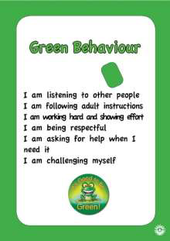

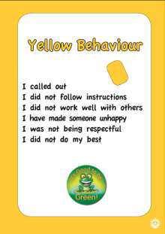

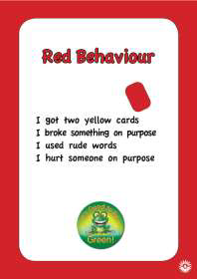
Parents will be called or sent a letter if their child reaches a red card and has
displayed any of the listed red behaviours. A yellow slip will be sent home by the
class teacher if a child has had three or more yellow cards in the week. This will
allow the parent to discuss behaviour with their child and encourage improvements
the following week.
The management team in the school are on duty in a room each playtime and lunch
time and pupils who need time to reflect on school rules and the code of conduct
will spend time there to plan how they can remain on green.
If a child is repeatedly on red cards a meeting with parents and teachers will be
held to produce an Individual Behaviour Plan. This plan will be actioned to support
the child to follow the Code of Conduct and the agreed rules of school.
I plan to set up a power point explaining each part of the system at the next open
parent event but hopefully your child will be able to tell you about how the system
is working in their own class. We had a launch assembly on Tuesday and the
system was outlined to all pupils and all staff.
Thank you for your anticipated support which should promote good behaviours in all
aspects of school life.
Yours sincerely,
Mrs Lynn Service
DHT

