Aberdeenshire
Progression Framework
Numeracy and Mathematics

INTERIM V2 December 15

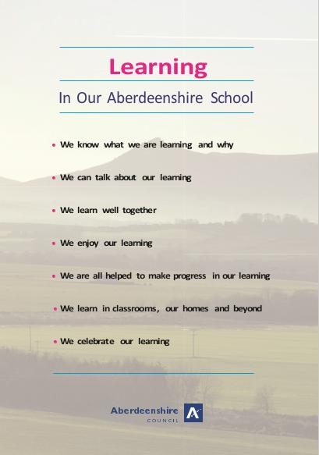
Contents

SECTION 1 NUMERACY AND MATHEMATICS GUIDANCE

Page 5 – Introduction

Page 6 – Context

Page 7 – Skills for Learning, Life and Work

Page 7 – Effective Learning and Teaching

Page 11 – Monitoring Progress and Achievement

Page 11 – Benchmarks

SECTION 2 PROGRESSION FRAMEWORK

Page 14 – Guidelines for using the framework

Significant Aspect of Learning – Using knowledge and understanding of the number system, patterns and relationships
Page 16 – Progression
Page 43 – Benchmarks

Significant Aspect of Learning – Using knowledge and understanding of measurement and its application
Page 48 - Progression
Page 57 – Benchmarks

Significant Aspect of Learning – Researching and evaluating data to assess risks and make informed choices
Page 61 - Progression
Page 69 - Benchmarks

Significant Aspect of Learning – Using knowledge and understanding of shape and space
Page 72 - Progression

SECTION 3 LEARNING TEACHING AND ASSESSMENT: PROFESSIONAL CURRICULUM
TOOL

Page 81 – Professional Curriculum Tool

Aberdeenshire
Progression Framework
Numeracy and Mathematics

Section 1 Guidance

INTERIM V2 December 15

INTRODUCTION

The Aberdeenshire Progression Framework for Numeracy and Mathematics sets out a clear progression for knowledge and understanding and related skills, from the Curriculum for Excellence and associated significant aspects of learning which are:
- Using knowledge and understanding of the number system, patterns and relationships
- Using knowledge and understanding of measurement and its application
- Researching and evaluating data to assess risks and make informed choices
- Using knowledge and understanding of shape and space
- Applying numeracy and mathematical skills

The progression framework sets out a continuum of learning through CfE Early Level to the end of the Broad General Education (Third/Fourth Levels). The progression framework is intended to assist teachers in their learning and teaching approaches as they plan curriculum and assess evidence of learning.
It is necessary to have a coherent approach to planning the curriculum, learning, teaching and assessment in which teachers’ practice embraces the following.
Four capacities

- Successful learners
- Confident individuals
- Effective contributors
- Responsible citizens
Four contexts

- Ethos and life of the school
- Curriculum areas and subjects
- IDL
- Opportunities for personal achievement

Seven design principles

- Challenge and enjoyment
- Breadth
- Progression
- Depth
- Personalisation and choice
- Coherence
- Relevance

The aims of the framework are to:
- support and enhance planning and assessment, based on skills, knowledge and understanding;
- provide staff with a structured progression for learning and teaching;
- enable the sharing of standards within schools, clusters and across Aberdeenshire;
- enable the development of skills for learning, life and work;

- facilitate the process of monitoring learners’ progress and achievement.

CONTEXT

Numeracy
The definition of Numeracy as defined in Curriculum for Excellence is:
Competence with numbers and using graphical skills in relation to basic number and number processes, estimation and rounding, aspects of fractions, percentages and decimal fractions, money, time, measure and aspects of information handling.

Being numerate helps us to function responsibly in everyday life and contribute effectively to society. It increases our opportunities within the world of work and establishes foundations which can be built upon through lifelong learning. Numeracy is not only a subset of mathematics; it is also a life skill which permeates and supports all areas of learning, allowing young people access to the wider curriculum.

We are numerate if we have developed the confidence and competence in using number which will allow individuals to solve problems, analyse information and make informed decisions based on calculations.
(Curriculum for Excellence: Numeracy across Learning, Scottish Government 2009)

Numeracy is a fundamental life skill. Being numerate involves developing a confidence and competence in calculating, problem solving, accessing and interpreting information, weighing up different options and hence making informed responsible lifestyle choices. It gives increased opportunities within the world of work and provides individuals with the knowledge, concepts and skills required for lifelong learning.

Mathematics
Mathematics is a creative subject. Having good mathematical skills allows us to spot patterns, use knowledge and skills in new contexts, ask good questions, make connections, solve problems, analyse and interpret information and make sense of the world around us.

Mathematics equips us with many of the skills required for life, learning and work. Understanding the part that mathematics plays in almost all aspects of life is crucial. This reinforces the need for mathematics to play an integral part in lifelong learning and be appreciated for the richness it brings.
Mathematics: Principles and Practice

Furthermore, the Mathematics Principles and Practice paper outlines the importance of Mathematics:
Mathematics is important in our everyday life, allowing us to make sense of the world around us and to manage our lives. Using mathematics enables us to model real-life situations and make connections and informed predictions. It equips us with the skills we need to interpret and analyse information, simplify and solve problems, assess risk and make informed decisions.
Mathematics Principles and practice
SKILLS FOR LEARNING, LIFE AND WORK

All of our young people from the early stages onwards in schools are entitled to opportunities to develop their skills in learning, life and work. The development of these skills is essential to life-long learning. This will enable young people to become flexible and adaptable as they progress into adulthood. Furthermore, this will enhance the development of resilience, self-esteem and confidence that they will require to flourish in the future.

EFFECTIVE LEARNING AND TEACHING

The experiences and outcomes and progressions detailed in this framework promote and support effective learning and teaching methodologies which will stimulate the interest of children and young people and promote creativity and ingenuity.
A rich and supportive learning environment will support a skilful mix of a variety of approaches, including:

- planned active learning which provides opportunities to observe, explore, investigate, experiment, play, discuss and reflect modelling and scaffolding the development of mathematical thinking skills;
- learning collaboratively and independently;
- opportunities for discussion, communication and explanation of thinking;
- developing mental agility;
- building on the principles of Assessment is for Learning, ensuring that young people understand the purpose and relevance of what they are learning;
- developing problem-solving capabilities and critical thinking skills;
- frequently asking children to explain their thinking;
- use of relevant contexts and experiences, familiar to children and young people;
- using technology in appropriate and effective ways;
- making frequent links across the curriculum, so that concepts and skills are developed further by being applied in different, relevant contexts;
- promoting an interest and enthusiasm for numeracy.

Developing number sense
The development of number sense is very important. Learners need access to a range of strategies for calculating and problem solving, and should be encouraged to develop their own strategies. There needs to be a focus on the use of mathematical vocabulary and learners should be given frequent opportunities to explain their thinking and share their learning with others.

Teachers will plan to establish and consolidate children’s fundamental numeracy skills using imaginative, interactive approaches, so that young people develop a sound understanding of number. Through such approaches they will grow in confidence in recall and use of number bonds and multiplication facts, in their understanding of place-value, and in the application of mental strategies. Teachers will reinforce these skills continually throughout the education of each child and young person.

From the early stages onwards, children and young people should experience success in numeracy and mathematics and develop the confidence to take risks, ask questions and explore alternative solutions without fear of being wrong. They will enjoy exploring and applying mathematical concepts to understand and solve problems, explaining their thinking and presenting their solutions to others in a variety of ways.

Problem solving
Mathematics is at its most powerful when the knowledge and understanding that have been developed are used to solve problems. Problem solving will be at the heart of all our learning and teaching. We should regularly encourage children and young people to explore different options: ‘what would happen if...?’ is the fundamental question for teachers and learners to ask as mathematical thinking develops.
Through real contexts, learners will be supported in developing an awareness of the relevance of the concepts and relationships they encounter in their daily lives. Interdisciplinary studies, where appropriate, will serve as a useful tool for reinforcing prior learning, as well as making meaningful links between subject areas.

In Aberdeenshire, we endorse Co-operative Learning as one of the research based approaches which has a positive impact on learning.

Co-operative Learning

Research has shown that co-operative learning provides a rich context for learners to develop personal and social interaction in reaching learning goals and in nurturing personal confidence. For co-operative learning to take place there requires to be:

- Positive Interdependence
- Individual Accountability
- Social Skills
- Face to Face Interactions
- Group Processing

The context of a co-operative learning task sets a core learning goal together with a social goal to allow young people not only to know when they are succeeding in their learning but also how their contribution has helped the group reach their goal. Co-operative learning has shown to be an effective tool in supporting the delivery of many aspects of Numeracy and Mathematics.

Well planned learning, teaching and assessment provide opportunities for children and young people to learn and demonstrate their learning across the significant aspects of learning in Numeracy and Mathematics through the experience of breadth, challenge and application.
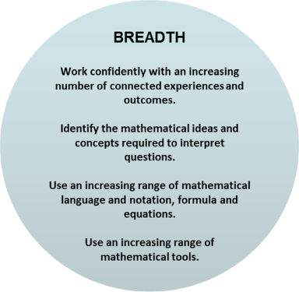
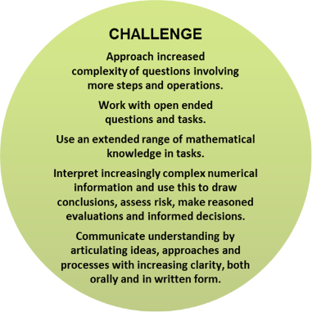
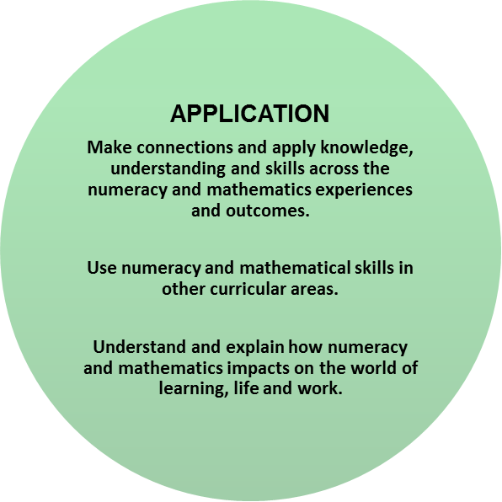

When teaching for effective learning, reference should be made to Aberdeenshire’s Learning Teaching and Assessment: Professional Curriculum Tool which outlines guidance for teachers in supporting the principles of ‘Assessment is for Learning’.
Success Criteria
Learning Intentions
The Learner
Clear, relevant and measurable definitions of success criteria. Learners involved in creating them in pupil language.
Planning together for
learning, teaching and assessment

Standards and expectations for
planned learning

Key

Professional Practice
features of effective professional practice

Learning Experiences
Evidence

Rich experiences planned to take account of the Es and Os and the design principles
A range of appropriate evidence

The Learner

Professional Action
professional actions for improvement

Assessment Approaches
Feedback and Next Steps
Timely and effective feedback supports the planning of pupils’ next steps in learning

Assess: Progress
Assess: Breadth, challenge, application
Collaborative approaches to evaluate the evidence of learning

Evaluate Learning

Learning Teaching and Assessment: Professional Curriculum Tool

This tool can be used
- to provide an opportunity to reflect on effective practice in learning, teaching and assessment in the context of Aberdeenshire’s progression frameworks.
- to allow practitioners to ‘dip into’ aspects of the learning, teaching and assessment process in order to reflect on their practice
- to inform planning for learning, teaching, moderation and assessment
- to support professional learning and/or moderation activities within a school or cluster
Key references used in this resource
- Taking a Closer Look at the National Assessment Resource (Education Scotland 2013)
- The Learning Set (Learning Unlimited 2000

MONITORING PROGRESS AND ACHIEVEMENT

Assessment of progress in Numeracy and Mathematics will focus on judgements about the success of children and young people in:
- developing key Numeracy and Mathematics skills;
- applying their skills in their learning, in their daily lives and in preparing for the world of work.

Evidence of progress in Numeracy and Mathematics should be gathered as part of day-to-day learning as well as across the curriculum and it should complement the evidence gathered in discrete Numeracy and Mathematics) lessons. To achieve this, a shared understanding of expectations is essential. This will ensure consistency of approach in sharing standards.

Learners’ progress should be defined in terms of breadth and depth of achievement. Emphasis should be placed not just on how much, but how well they learn.

BENCHMARKS

The benchmarks which accompany this framework outline the standards and expectations which will enable schools to identify how their learners are performing at each year stage. In other words, the benchmarks for Numeracy and Mathematics set out what can reasonably be expected of most pupils by the end of each year of schooling.

Effective benchmarking of standards and expectations for Numeracy and Mathematics needs to be a systematic and rigorous process which:

- starts with the identification of benchmark measures that define the “good standard” against which comparison can be made;

- involves some investigation and/or analysis of the processes and practices that underlie that good performance;

- identifies and/or shares good or excellent practice that school(s) can learn from and use to drive improvement.

By specifying the essential indicators of “good” performance, the benchmarks which accompany this framework will enable schools to:

- indicate how their learners are performing;
- understand how they and their learners perform in comparison to other learners;
- compare performance across schools and year-on-year.

Benchmarking for Improvement

The purposes of the benchmarks for Numeracy and Mathematics are to:

- promote quality teaching and learning in the classroom;
- nurture success for all students;
- assist teachers and schools in monitoring and tracking student progress;
- evaluate the success of teaching and learning programmes;
- inform next steps for learners and their learning;
- target/identify students who need additional support;
- report to pupils and families;
- identify appropriate professional development for staff.
Aberdeenshire
Progression Framework

Numeracy and Mathematics

Section 2

GUIDELINES FOR USING THE PROGRESSION FRAMEWORK

This framework sets out a clear progression for skills, knowledge and understanding from the following Curriculum for Excellence Numeracy and Mathematics Significant Aspects of Learning:

Using knowledge and understanding of the number system, patterns and relationships | Using knowledge and understanding of measurement and its application |  | Researching and evaluating data to assess risks and make informed choices
Using knowledge and understanding of shape and space |  | Applying numeracy and mathematical skills

The purpose of this document is to offer a continuum of learning through to the end of the Broad General Education (CfE Early – Third/Fourth Levels). The progression is intended to assist teachers as they plan their Numeracy and Mathematics curriculum and assess evidence of learning.

Level | Stage
Early | The pre-school years and P1, or later for some.
First | To the end of P4, but earlier or later for some.
Second | To the end of P7, but earlier or later for some.
Third and Fourth | S1 to S3, but earlier for some. The fourth level broadly equates to Scottish Credit and Qualifications Framework level 4.  The fourth level experiences and outcomes are intended to provide possibilities for choice. Young people's programmes will not include all of the fourth level outcomes.

The aims of the Progression are to:
- enhance planning and assessment;
- provide staff with a framework to promote progression in learning and teaching;
- enable the sharing of standards within schools and across school clusters.
The document is structured using each of the Numeracy and Mathematics significant aspects of learning. These are then sub-divided further using Curriculum levels and the CfE Experiences and Outcomes. The document details the learner’s progression within and through each of the Levels.
The document details the learner’s progression within and through each of the Levels.

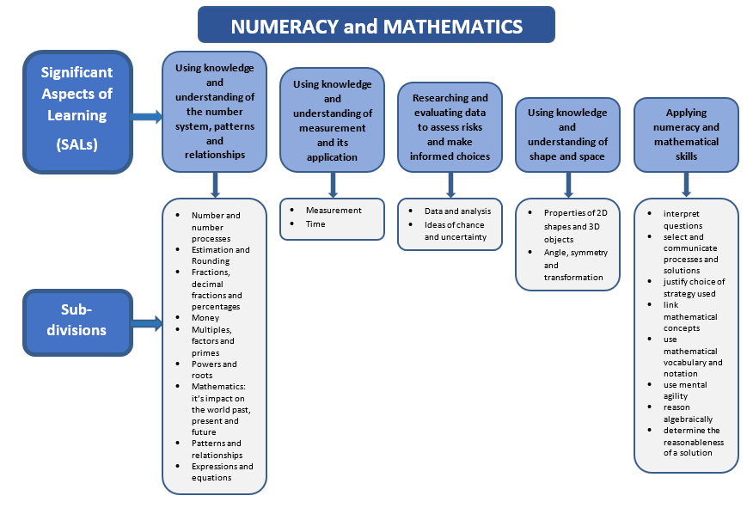

Using knowledge and understanding of the Number system, Patterns and Relationships

Progression

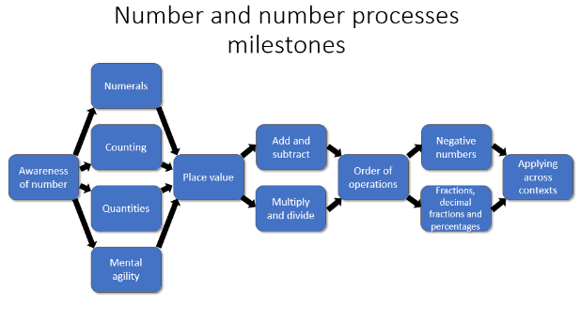

Significant aspect of learning:
Applying numeracy and mathematical skills
It is important that learners develop numeracy and mathematical skills as they build their knowledge and understanding. As learners progress, they should demonstrate an increasing sophistication in their ability to:
• interpret questions
• select and communicate processes and solutions
• justify choice of strategy used
• link mathematical concepts
• use mathematical vocabulary and notation
• use mental agility
• reason algebraically
• determine the reasonableness of a solution
These skills should be evident across the other significant aspects of learning in Numeracy and Mathematics. Staff should actively promote the development of these skills and ensure they are embedded in planning for learning, teaching and assessment.
Number and number processes |  | Significant aspect of learning:  Use knowledge and understanding of the number system, patterns and relationships
 | Milestone | During Early Level |  | By the end of Early Level
I have explored numbers, understanding that they represent quantities, and I can use them to count, create sequences and describe order.  MNU 0-02a | Awareness of number | - I can describe groups of objects by saying which is bigger, smaller or if they are the same.  - I can sort the objects using familiar or given criteria e.g. colour. |  | - I can count the objects to decide which has the most or least.  - I can sort and create groups of objects by number. I can describe their position using ordinal numbers.
 | Numerals | - I can identify all the numbers from 0-20.  - I can say the number word sequences forwards and backwards in the range 0-20. |  | - I can identify all the numbers from 0-100.  - I can say the number word sequences forwards and backwards in the range 0-100.
 | Quantities  - Subitising  - Arrays | - I recognise patterns to 5, i.e. subitise. |  | - I recognise patterns to 10.
I use practical materials and can ‘count on and back’ to help me to understand addition and subtraction, recording my ideas and solutions in different ways.  MNU 0-03a | Counting  - The importance of zero  - One-to-one correspondence  - Developing counting skills  - Language  - Counting forwards and backwards | - I can match the counting words with objects by touching each in turn.  - I can use concrete materials to count a set of objects.  - I can solve addition and subtraction problems using a count all strategy and materials.  - I know that when we count we start from zero.  - I can skip count for easy multiples 2 and 5.  - I know that the last number I count tells me the total of the set.  - I can describe groups of objects by saying which is bigger, smaller or if they are the same.  - I can say the number before and after a given number in the range 0-10 i.e. count on and back. |  | - I know that it does not matter which way I add the numbers I get the same answer.  - I can solve addition and subtraction problems using a count all strategy and imaging.  - I can demonstrate that when we add on zero the number stays the same.  - I can demonstrate that when we subtract zero the number stays the same.  - I can use counting words in a one-to-one relationship.  - I can skip count for a range of multiples 2, 5, 10.  - I can say the number before and after a given number in the range 0-20 i.e. count on and back.
 | Mental agility | - I have learned the basic facts for addition and subtraction and number families up to 5 by investigating patterns and groupings. |  | - I have learned the basic facts for addition and subtraction and number families to 10.
 | Milestone | At the beginning of First Level | During First Level |  | By the end of First Level
I have investigated how whole numbers are constructed, can understand the importance of zero within the system and can use my knowledge to explain the link between a digit, its place and its value.  MNU 1-02a | Counting  - The importance of zero  - One-to-one correspondence  - Developing counting skills  - Language  - Counting forwards and backwards | - I count on and back to solve number problems.  - I can say the number before and after a given number in the range 0-20 i.e. count on and back. | - I use the commutative property to add by counting from the biggest number.  - I can say the number before and after a given number in the range 0-100 i.e. count on and back. |  | - I can say the number before and after a given number in the range 0-1000 i.e. count on and back.
 | Quantities  - Subitising  - Arrays | - I can make groups of numbers and write their number sentence. | - I can count arrays of numbers. |  | - I can quickly build, describe and count arrays of numbers.
 | Place value  - Zero as a place holder  - Language of place value  - Grouping and partitioning  - Working with decimal fractions  - Mental agility | - I know the value of the number depends on where the digits are placed.  - Know zero is a place holder.  - I can describe the value of each digit in a numeral to at least 100.  - I am beginning to build my knowledge of multiplication facts. | - I know how to construct 2 digit numbers.  - I can be flexible in the way I partition numbers to make calculations easy.  - I can recall some multiplication facts from memory. |  | - I know how to construct 2 digit numbers and can put them in order.  - I can describe the value of each digit in a numeral to at least 1000.  - I can use place value to partition numbers. I also use other forms of partitioning such as tidy numbers to help during calculation.  - I can recall some multiplication and division facts from memory.  - I have a range of mental methods to solve problems.
I can use addition, subtraction, multiplication and division when solving problems, making best use of the mental strategies and written skills I have developed. MNU 1-03a | Mental agility | - I have learned the basic facts for addition and subtraction and number families to 20. | - I have learned the basic facts for addition and subtraction and number families to 100. |  | - I have a range of mental methods to solve problems.
 | Add and subtract  - Relationship between addition and subtraction  - Algorithms | - I can use a number line or pictures to show my calculation strategy.  - I can describe how I solve a variety of addition and subtraction tasks to 20 using my knowledge of inverse operations. | - I can use doubles, halves and similar strategies to add and subtract numbers.  - I can use the associative property to make addition easier. |  | - I can use an empty number line or my own jottings to show the jumps I make when solving problems.  - I can describe how I solve a variety of higher decade addition and subtraction tasks using my knowledge of inverse operations.
 | Multiply and divide  - Relationship between multiplication and division | - I use repeated addition and subtraction to solve multiplication and division problems.  - I can make array patterns to show multiplication.  - I know when we divide by 2 we share between 2 using our knowledge of the 2 times table. | - I can use jumps groups and sharing to solve multiplication problems.  - I know when we divide by 2,5,10 we share using our knowledge of the times tables. |  | - I can use jumps, groups and sharing to solve multiplication and division problems.  - I know when we divide by 2,3,4,5,10 we share using our knowledge of the times tables.
 | Milestone | At the beginning of Second Level | During Second Level |  | By the end of Second Level
Having determined which calculations are needed, I can solve problems involving whole numbers using a range of methods, sharing my approaches and solutions with others.  MNU 2-03a | Add and subtract  - Relationship between addition and subtraction  - Algorithms | - I can record the results of calculations using (horizontal) number sentences.  - I use column addition and subtraction when it is appropriate. | - I can demonstrate the calculation on a number line or with a diagram. |  | - I have a range of mental strategies that I can use to solve problems with whole numbers.
 | Multiply and divide  - Relationship between multiplication and division | - I can multiply by common multiples of 10.  - I can recall some multiplication facts from memory.  - I know when we divide within the times tables we share using our knowledge of the times tables. | - I can multiply and divide by common multiples of 10.  - I can recall al the multiplication facts from memory. |  | - I can multiply and divide by common multiples of 10 and powers of 10.  - I can recall all of the multiplication and division facts from memory.  - I can perform short multiplication and division by a single digit number.  - I know when we divide outwith the times tables, we share using our knowledge of the times tables.
Having explored the need for rules for the order of operations in number calculations, I can apply them correctly when solving simple problems.  MTH 2-03c | Order of operations  - Understanding and application of the order of operations  - Commutative, distributive and associative properties | - I have explored the rules for the order of operations of x, ÷, +, -.  - I understand that addition is commutative.  - I understand that addition is associative and can use this to solve a problem by grouping numbers.  - I understand the distributive law and can split numbers to solve multiplication calculations outwith the times tables. e.g. 5x15=5x10+5x5. | - I can apply the order of operations to problems involving x, ÷, +, -.  - I can use the commutative property of addition to solve a problem by changing the order of the numbers.  - I can use the associative property of addition to solve a problem by grouping numbers. |  | - I can apply the order of operations to problems involving brackets and indices.  - I understand that multiplication is commutative and can use this to solve a problem by changing the order of the factors.  - I understand that multiplication is associative and can use this to solve a problem by grouping numbers.
I can show my understanding of how the number line extends to include numbers less than zero and have investigated how these numbers occur and are used.  MNU 2-04a | Negative numbers  - Integers  - Ordering  - Calculations  - Application in real life contexts | - I can explain what negative numbers are and when they might be used. | - I can construct a number line to answer questions that involve negative numbers. |  | - I can solve problems involving negative numbers mentally.  - I can use negative numbers in everyday contexts and familiar applications.
I have extended the range of whole numbers I can work with and having explored how decimal fractions are constructed, can explain the link between a digit, its place and its value.  MNU 2-02a  I have explored the contexts in which problems involving decimal fractions occur and can solve related problems using a variety of methods.  MNU 2-03b | Fractions, decimal fractions and percentages  - Interrelationship | - I can use place value to partition numbers.  - See Fractions, Decimal Fractions and Percentages. | - I have extended my understanding of place value to decimal numbers. I use the notation and vocabulary consistently. |  | - I can explain how zero is used as a place holder for whole numbers and decimals.  - I have a range of mental strategies that I can use to solve problems with whole numbers, decimals and fractions.
 | Milestone | During Third Level |  | By the end of Third Level
I can use my understanding of numbers less than zero to solve simple problems in context.  MNU 3-04a | Negative numbers  - Integers  - Ordering  - Calculations  - Application in real life contexts | - I can put whole numbers, negative numbers and decimals in order for simple problems. |  | - I can order numbers, including decimals and negative numbers.  - I have a range of strategies that I can use to solve problems with whole numbers, negative numbers, decimals and fractions.
I can continue to recall number facts quickly and use them accurately when making calculations.  MNU 3-03b | Fractions, decimal fractions and percentages  - Interrelationship | - I have a range of mental strategies that I can use to solve problems with whole numbers, negative numbers, decimals and fractions. |  | - In addition to my mental strategies I can also use column addition and subtraction for whole numbers and decimals, and multiply and divide by a single digit number.
I can use a variety of methods to solve number problems in familiar contexts, clearly communicating my processes and solutions.  MNU 3-03a | Applying across contexts | - I have a range of mental strategies that I can use to solve problems in familiar contexts with whole numbers, negative numbers, decimal fractions and fractions. |  | - In addition to my mental strategies I can also use column addition and subtraction, and multiply and divide by a single digit number for whole numbers and decimals to solve problems in a familiar context.  - I can use long multiplication to solve problems in a familiar context.
 | Milestone | During Fourth Level |  | By the end of Fourth Level
Having recognised similarities between new problems and problems I have solved before, I can carry out the necessary calculations to solve problems set in unfamiliar contexts.  MNU 4-03a | Applying across contexts | - I can solve problems involving whole numbers, negative numbers, decimal fractions and fractions set in familiar contexts. |  | - I can solve problems involving whole numbers, negative numbers, decimal fractions and fractions set in unfamiliar contexts.

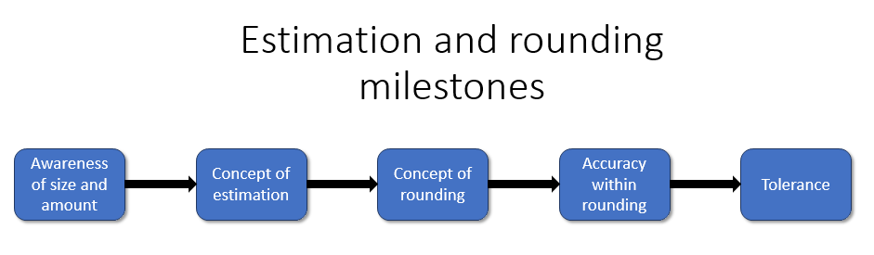

Significant aspect of learning:
Applying numeracy and mathematical skills
It is important that learners develop numeracy and mathematical skills as they build their knowledge and understanding. As learners progress, they should demonstrate an increasing sophistication in their ability to:
• interpret questions
• select and communicate processes and solutions
• justify choice of strategy used
• link mathematical concepts
• use mathematical vocabulary and notation
• use mental agility
• reason algebraically
• determine the reasonableness of a solution
These skills should be evident across the other significant aspects of learning in Numeracy and Mathematics. Staff should actively promote the development of these skills and ensure they are embedded in planning for learning, teaching and assessment.

Estimation and rounding |  | Significant aspect of learning:  Use knowledge and understanding of the number system, patterns and relationships
 | Milestone | During Early Level |  | By the end of Early Level
I am developing a sense of size and amount by observing, exploring, using and communicating with others about things in the world around me  MNU 0-01a | Awareness of size and amount | - I can describe groups of objects by saying which is bigger, smaller or if they are the same.  - I can sort my objects into groups using simple criteria, explain how I did this and talk about their position using first, second etc. |  | - I can count the objects to decide which has the most or least.  - I can sort and create groups of objects by number. I can describe their position using ordinal numbers.
 | Milestone | At the beginning of First Level | During First Level |  | By the end of First Level
I can share ideas with others to develop ways of estimating the answer to a calculation or problem, work out the actual answer, then check my solution by comparing it with the estimate.  MNU 1-01a | Concept of estimation | - I can estimate to the nearest 10 using a number line.  - I can make reasonable estimates of small quantities to 10.  - I can choose the best approximate answer to additions and subtractions involving 2 digit numbers. | - I can make reasonable estimates of small quantities to 20.  - I can choose the best approximate answer to additions and subtractions involving 3 digit numbers. |  | - I can estimate the position of numbers to 100 and beyond on a number line.  - I can make reasonable estimates of quantities to 100.  - I can compare an estimation with the answer to a calculation and decide if the answer is reasonable.
 | Concept of rounding | - I can round numbers to the nearest ten. | - I can round numbers to the nearest 100. |  | - I can round numbers to the nearest 1000.
 | Milestone | At the beginning of Second Level | During Second Level |  | By the end of Second Level
I can use my knowledge of rounding to routinely estimate the answer to a problem then, after calculating, decide if my answer is reasonable, sharing my solution with others.  MNU 2-01a | Concept of rounding | - I can round numbers to the nearest unit. | - I can round numbers to 1 decimal place. |  | - I can round numbers to 2 decimal places.
 | Accuracy within rounding | - I understand how rounded numbers can be used to estimate. | - I can use rounded numbers to estimate. |  | - I can use rounded numbers to estimate and check reasonable answers.
 | Milestone | During Third Level |  | By the end of Third Level
I can round a number using an appropriate degree of accuracy, having taken into account the context of the problem.  MNU 3-01a | Accuracy within rounding | - I can round a number to 1 significant figure. |  | - I can round a number to 3 significant figures.  - I use the context of the problem to decide on a suitable degree of accuracy.
 | Milestone | During Fourth Level |  | By the end of Fourth Level
Having investigated the practical impact of inaccuracy and error, I can use my knowledge of tolerance when choosing the required degree of accuracy to make real-life calculations.  MNU 4-01a | Tolerance | - I know what is meant by tolerance.  - I can write tolerances in the form 200cm± 2cm. |  | - I can interpret tolerances e.g. 200cm ± 2cm.  - I know that rounding numbers inappropriately in a calculation will lead to an insufficiently accurate answer.  - I can analyse a problem and choose an appropriate degree of accuracy for rounding.
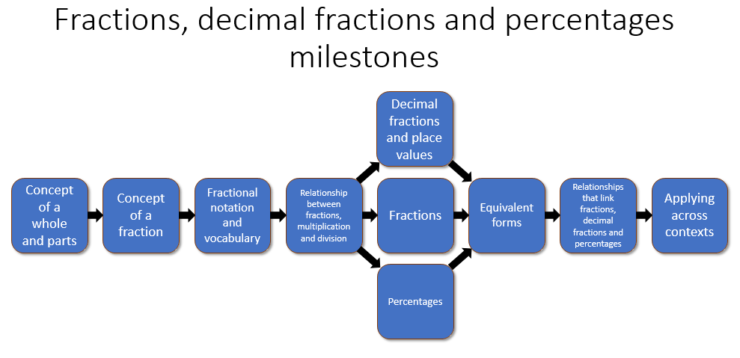
Significant aspect of learning:
Applying numeracy and mathematical skills
It is important that learners develop numeracy and mathematical skills as they build their knowledge and understanding. As learners progress, they should demonstrate an increasing sophistication in their ability to:
• interpret questions
• select and communicate processes and solutions
• justify choice of strategy used
• link mathematical concepts
• use mathematical vocabulary and notation
• use mental agility
• reason algebraically
• determine the reasonableness of a solution
These skills should be evident across the other significant aspects of learning in Numeracy and Mathematics. Staff should actively promote the development of these skills and ensure they are embedded in planning for learning, teaching and assessment.

Fractions, decimal fractions and percentages |  | Significant aspect of learning:  Use knowledge and understanding of the number system, patterns and relationships
 | Milestone | During Early Level |  | By the end of Early Level
I can share out a group of items by making smaller groups and can split a whole object into smaller parts.  MNU 0-07a | Concept of a whole and parts  - One object, shape or quantity can be shared into parts  - A group of items can be shared out  - Equal parts | - I can split a whole object into halves.  - I can share out a group of items, dealing them out one at a time using concrete materials.  - I know that I have to use all of the whole. |  | - I can split a whole object into equally sized parts and use the associated vocabulary.  - I can share out a group of items and find out how many are in the smaller groups. I can decide what to do with any leftovers if they can be shared further or not.  - I can use symmetry to partition groups into two, four or eight parts and use the associated vocabulary.
 | Milestone | At the beginning of First Level | During First Level |  | By the end of First Level
Having explored fractions by taking part in practical activities, I can show my understanding of  - how a single item can be shared equally  - the notation and vocabulary associated with fractions  - where simple fractions lie on the number line  MNU 1-07a | Concept of a fraction  - Fractions with equal parts  - Sharing with no remainder  - Equal sharing | - I am aware that any sized group of items can be shared equally. | - I can show how a single object can be divided into a given common fraction including halves, quarters and eighths. |  | - I understand that a fraction is an equal part of a whole.
 | Fractional notation and vocabulary  - Numerator and denominator | - I can show how to share a single item equally and use the associated vocabulary.  - I understand that the denominator tells how many equal parts the whole has been divided into and the numerator tells how many of the equal parts are used. | - I can link the number of shares with the vocabulary of fractions e.g. if I make 6 equal portions, then each portion is one sixth of the whole.  - I am beginning to compare simple fractions, e.g. quarters. |  | - I can read and write fractions using fraction notation e.g.one eighth is $\frac{1}{8}$.  - I understand that a comparison can be made between fractions with the same denominator.
Through exploring how groups of items can be shared equally, I can find a fraction of an amount by applying my knowledge of division.  MNU 1-07b | Relationship between fractions, multiplication and division | - I can use concrete materials, to find the fraction of an amount. | - I can use pictures or informal jottings to find the fraction of an amount. |  | - I can find the fraction of an amount using division.
Through taking part in practical activities including use of pictorial representations, I can demonstrate my understanding of simple fractions which are equivalent.  MTH 1-07c | Equivalent forms | - I can use materials to partition and re-partition amounts to show fractions that are equivalent. | - I can draw pictures to partition and re-partition amounts to show fractions that are equivalent. I record my answers using words e.g. 1 third=2 sixths. |  | - I can draw pictures to partition and re-partition amounts to show fractions that are equivalent and record my answers using fraction notation.
 | Milestone | At the beginning of Second Level | During Second Level |  | By the end of Second Level
I have investigated the everyday contexts in which simple fractions, percentages or decimal fractions are used and can carry out the necessary calculations to solve related problems.  MNU 2-07a | Decimal fractions and place value  - The decimal point | - I can work with decimal fractions to 1 decimal place (tenths) including addition and subtraction.  - I can add/subtract decimal fractions with 1 decimal place.  - I can multiply/divide decimal fractions with 1 decimal place by a whole number.  - I can multiply/divide decimal fractions by 10.  - I know that the decimal point separates the whole number part from the fractional part. | - I can work with decimal fractions to 2 decimal places (tenths, hundredths).  - I can add/subtract decimal fractions with 2 decimal places.  - I can multiply/divide decimal fractions with 2 decimal places by a whole number.  - I can multiply/divide decimal fractions by 100. |  | - I can work with decimal fractions to 3 decimal places (tenths, hundredths and thousandths).  - I can add/subtract decimal fractions with 3 decimal places.  - I can multiply/divide decimal fractions with 3 decimal places by a whole number.  - I can multiply/divide decimal fractions by 1000.
 | Fractions | - I can find the fraction of an amount by using concrete materials, pictures or informal jottings e.g. $\frac{2}{3}of 15$.  - I know that a mixed number is one with a whole number and a fraction part e.g. $4\frac{3}{4}$.  - I know that an improper fraction is a fraction greater than one where the numerator is greater than the denominator e.g. $\frac{8}{3}$. | - I can find the fraction of an amount by using pictures or informal jottings e.g. $\frac{2}{3}of 15$.  - I can convert an improper fraction to a mixed number. |  | - I can find the fraction of an amount by using multiplication and division e.g. $\frac{2}{3}of 15$.  - I can convert between mixed numbers and improper fractions e.g. $\frac{5}{3}=1\frac{2}{3}$.
 | Percentages | - I understand that a percentage is a fraction with a denominator of 100.  - I can carry out calculations with 25%, 50% and 100%. | - I can carry out calculations with 1%, 10%, 20%, 25%, 50%, 75% and 100%. |  | - I can carry out calculations with any percentage.
I have investigated how a set of equivalent fractions can be created, understanding the meaning of simplest form, and can apply my knowledge to compare and order the most commonly used fractions  MTH 2-07c | Equivalent forms | - I can use multiplication and division to find equivalent fractions. | - I can use equivalent fractions to compare the size of commonly used fractions and put them in order. |  | - I can reduce fractions to the simplest form.
I can show the equivalent forms of simple fractions, decimal fractions and percentages and can choose my preferred form when solving a problem, explaining my choice of method.  MNU 2-07b | Relationships that link fractions, decimal fractions and percentages  - Comparisons between fractions, decimal fractions and percentages | - I understand what is meant by the term equivalent and can show the equivalence between fractions and decimal fractions using counters or a picture.  - I can calculate with simple fractions and decimal fractions to solve simple problems in everyday contexts.  - I can show where simple fractions and decimal fractions lie on a number.  - I can count up in fractions, showing this on a number line. | - I can show the equivalence between fractions, decimal fractions and percentages using counters or a picture e.g. ½ = 50% = 0.5 because all 3 amounts cover half a square.  - I can calculate with simple fractions, decimal fractions and percentages to solve problems in everyday contexts.  - I can show where simple fractions and decimal fractions lie on a number line and use my knowledge of fractions to estimate where other common fractions and decimal fractions lie. |  | - I can show the equivalent forms and convert between simple fractions, decimal fractions and percentages.  - I can calculate with simple fractions, decimal fractions and percentages to solve problems in everyday contexts, choose my preferred form and explain my choices.  - I can show where any fraction, decimal fraction or percentage lies on a number line.
 | Milestone | During Third Level |  | - By the end of Third Level
I can solve problems by carrying out calculations with a wide range of fractions, decimal fractions and percentages, using my answers to make comparisons and informed choices for real-life situations.  MNU 3-07a  By applying my knowledge of equivalent fractions and common multiples, I can add and subtract commonly used fractions.  MTH 3-07b  Having used practical, pictorial and written methods to develop my understanding, I can convert between whole or mixed numbers and fractions.  MTH 3-07c  I can show how quantities that are related can be increased or decreased proportionally and apply this to solve problems in everyday contexts.  MNU 3-08a | Applying across contexts  - Applying across contexts  - Linking fractions and ratio  - Proportion | - I can add and subtract simple fractions and mixed numbers with common denominators.  - I can solve problems with a wide range of fractions, decimal fractions and percentages.  - I can increase and decrease quantities proportionally using multiplication and division. |  | - I can add and subtract simple fractions and mixed numbers e.g. $\frac{3}{4}+2\frac{3}{8}$.  - I understand the relationship between proportion and ratio.
 | Milestone | During Fourth Level |  | - By the end of Fourth Level
I can choose the most appropriate form of fractions, decimal fractions and percentages to use when making calculations mentally, in written form or using technology, then use my solutions to make comparisons, decisions and choices.  MNU 4-07a  I can solve problems involving fractions and mixed numbers in context, using addition, subtraction or multiplication.  MTH 4-07b  Using proportion, I can calculate the change in one quantity caused by a change in a related quantity and solve real-life problems  MNU 4-08a | Applying across contexts  - Applying across contexts  - Linking fractions and ratio  - Proportion | - I can solve problems and use the solutions to make comparisons and informed choices for real-life situations. |  | - I can multiply and divide fractions.  - I can increase and decrease quantities proportionally to solve problems in everyday contexts.

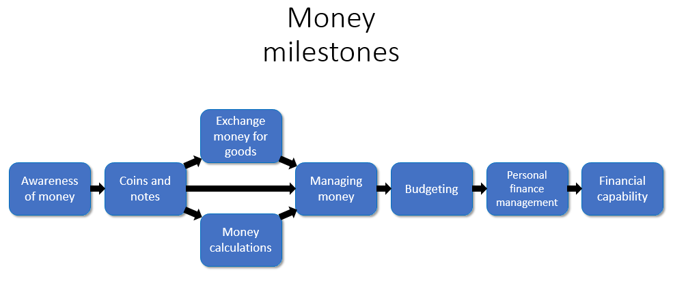
Significant aspect of learning:
Applying numeracy and mathematical skills
It is important that learners develop numeracy and mathematical skills as they build their knowledge and understanding. As learners progress, they should demonstrate an increasing sophistication in their ability to:
• interpret questions
• select and communicate processes and solutions
• justify choice of strategy used
• link mathematical concepts
• use mathematical vocabulary and notation
• use mental agility
• reason algebraically
• determine the reasonableness of a solution
These skills should be evident across the other significant aspects of learning in Numeracy and Mathematics. Staff should actively promote the development of these skills and ensure they are embedded in planning for learning, teaching and assessment.

Money |  | Significant aspect of learning:  Use knowledge and understanding of the number system, patterns and relationships
 | Milestone | During Early Level |  | By the end of Early Level
I am developing my awareness of how money is used and can recognise and use a range of coins.  MNU 0-09a | Awareness of money | - I am developing an awareness of how money is used in real life.  - I understand that coins have different values. |  | - I am developing an awareness that coins/money can be exchanged for goods and services.
 | Coins and notes  - Using coins and notes  - Real life contexts  - The interrelationship between different sets of coins and notes | - I can recognize the value of some coins. |  | - I can recognize the value of all coins.  - I can use a variety of coins in real life contexts.
 | Milestone | At the beginning of First Level | During First Level |  | By the end of First Level
I can use money to pay for items and can work out how much change I should receive.  MNU 1-09a  I have investigated how different combinations of coins and notes can be used to pay for goods or be given in change.  MNU 1-09b | Coins and notes  - Using coins and notes  - Real life contexts  - The interrelationship between different sets of coins and notes | - I can recognize notes and coins.  - I can read and write monetary values in pence.  - I use simple strategies to count money and keep a track of how much I have.  - I can use notes and coins to make up monetary values. | - I understand the relative value of notes and coins.  - I can read and write monetary values, including using the appropriate symbols.  - I am developing a range of mental strategies and informal jottings to count money and how much change is due.  - I can use a variety of notes and coins to make up monetary values and work out how to give change. |  | - I use the equivalence of pounds and pence when using money.  - I can read and write monetary values using correct notation including the decimal point.  - I use a range of mental strategies and informal jottings to calculate the cost of a collection of items and how much change they should get, in a range of contexts.  - I can use a variety of notes and coins to make up monetary values and work out the most efficient way to give change in real life contexts.
 | Milestone | At the beginning of Second Level | During Second Level |  | By the end of Second Level
I can manage money, compare costs from different retailers, and determine what I can afford to buy.  MNU 2-09a | Exchange money for goods  - Application in everyday life | - I can work out the cost of an item or selection of items. | - I can work out how much money I will have left over after paying for an item or selection of items. |  | - I can compare the price of goods against my given budget and determine if I can afford to buy them.  - I can solve real life problems involving money.
 | Money calculations  - Applying the four operations in calculations involving money | - I can read and write monetary values using the correct notation.  - I can add and subtract monetary values with a decimal point. | - I can use decimals in the context of money.  - I have further developed the range of written and mental calculation strategies to +,-,x and ÷ with money. |  | - I can use decimals and negative numbers in the context of money.  - I choose the best method of written and mental calculation strategies to add, subtract, multiply and divide with money and use technology when appropriate.
I understand the costs, benefits and risks of using bank cards to purchase goods or obtain cash and realise that budgeting is important.  MNU 2-09b  I can use the terms profit and loss in buying and selling activities and can make simple calculations for this.  MNU 2-09c | Managing money  - Profit and loss  - Best value  - Making informed financial decisions  - Bank cards | - I understand the terms profit and loss.  - I can find the cost of items from a range of sources.  - I can plan purchases within a given budget.  - I have investigated banks and their role. | - I can talk about profit and loss in buying and selling activities.  - I can find the cost of the same or similar items/services from a range of retailers to find the best value.  - I can plan purchases, making appropriate decisions within given budgeting constraints. |  | - I can talk about profit and loss in buying and selling activities and make calculations for this.  - I can find the cost of the same or similar items/services from a range of retailers and determine the best value including calculating discounts.  - I can use budgeting skills to make responsible decisions regarding spending.  - I know and use the vocabulary associated with personal banking and understand the use of bank cards.
 | Milestone | During Third Level |  | By the end of Third Level
When considering how to spend my money, I can source, compare and contrast different contracts and services, discuss their advantages and disadvantages, and explain which offer best value to me.  MNU 3-09a  I can budget effectively, making use of technology and other methods, to manage money and plan for future expenses.  MNU 3-09b | Budgeting | - I can use technology and other methods to keep a budget for an event e.g. planning a holiday.  - I can use the internet and other sources to find goods and services, compare them and discuss their advantages and disadvantages.  - I can calculate simple interest. |  | - I can use technology and other methods to budget effectively.  - I can plan personal spending and budget in a responsible way including planning for future spending.  - When considering how to spend my money, I can source, compare, and contrast different contracts and services, discuss their advantages and disadvantages and explain which offer best value to me.  - I have investigated the effects of interest and % rates in the context of contracts and services.
 | Milestone | During Fourth Level |  | By the end of Fourth Level
I can discuss and illustrate the facts I need to consider when determining what I can afford, in order to manage credit and debt and lead a responsible lifestyle. MNU 4-09a | Budgeting  - Debt  - Income  - Deductions  - Borrowing  - Salaries and pensions | - I know how to read information from wage slips, earnings summaries, budgets etc. |  | - I understand the terms credit and debt and I can explain their advantages and disadvantages.  - I understand the vocabulary associated with income e.g. gross, net pay, earnings, deductions, overtime, bonus etc.  - I can calculate income and deductions in order to find gross and net pay.
I can source information on earnings and deductions and use it when making calculations to determine net income.  MNU 4-09b | Personal finances management  - Making informed financial decisions | - I can work out the total of monthly/weekly bills.  - I can work out the total income and total expenditure. |  | - I can create a budget taking into account income and expenditure over the short and long term.  - As I plan ahead and budget I can make and explain decisions that lead to a responsible lifestyle.
I can research, compare and contrast a range of personal finance products and, after making calculations, explain my preferred choices.  MNU 4-09c | Financial capability | - I understand the vocabulary of financial products e.g. APR, repayment schemes, mutual etc.  - I know where to find information on personal financial products to source and compare them. |  | - I can use calculations to determine the differences between financial products to make informed decisions to decide which the best product to take is.  - I use a range of factors such as quality, depth of cover, reputation, future earnings, economy and ethical aspects to make my decisions.
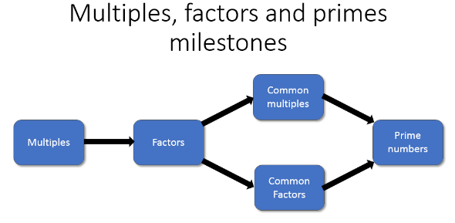
Significant aspect of learning:
Applying numeracy and mathematical skills
It is important that learners develop numeracy and mathematical skills as they build their knowledge and understanding. As learners progress, they should demonstrate an increasing sophistication in their ability to:
• interpret questions
• select and communicate processes and solutions
• justify choice of strategy used
• link mathematical concepts
• use mathematical vocabulary and notation
• use mental agility
• reason algebraically
• determine the reasonableness of a solution
These skills should be evident across the other significant aspects of learning in Numeracy and Mathematics. Staff should actively promote the development of these skills and ensure they are embedded in planning for learning, teaching and assessment.

Multiples, factors and primes |  | Significant aspect of learning:  Use knowledge and understanding of the number system, patterns and relationships
 | Milestone | At the beginning of Second Level | During Second Level |  | By the end of Second Level
Having explored the patterns and relationships in multiplication and division, I can investigate and identify the multiples and factors of numbers.  MTH 2-05a | Multiples | - I can describe what multiples are and how to generate a sequence of multiples.  - I can skip count forwards and backwards to identify multiples. | - I can use repeated addition, subtraction, doubles and other part-whole strategies to identify multiples. |  | - I use my knowledge of multiplication facts to identify multiples.  - I can identify multiples for fractions and decimals.
 | Factors | - I can describe what a factor is.  - I can find some of the factors of a simple number. | - I can find all of the factors of a simple number. |  | - I write factors in an organised list and use a strategy to check that I have found all the possible factors.
 | Milestone | During Third Level |  | By the end of Third Level
I have investigated strategies for identifying common multiples and common factors, explaining my ideas to others, and can apply my understanding to solve related problems.  MTH 3-05a | Common Multiples | - I can find the common multiples of a small set of numbers.  - I can identify the lowest common multiple of a small set of numbers. |  | - I can solve problems relating to multiples, common multiples and lowest common multiples.
 | Common Factors | - I can find the common factors of a small set of numbers.  - I can identify the highest common factor of a small set of numbers. |  | - I can solve problems relating to factors, common factors and highest common factors.
I can apply my understanding of factors to investigate and identify when a number is prime.  MTH 3-05b | Prime Numbers | - I can use my knowledge of factors to identify prime numbers. |  | - I can use a factor tree to identify prime factors.  - I can solve problems relating to prime numbers.

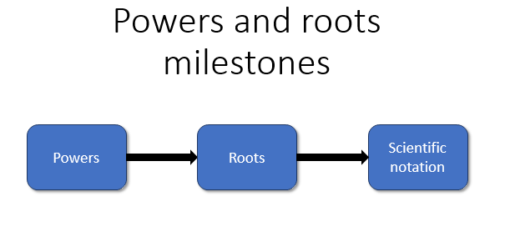
Significant aspect of learning:
Applying numeracy and mathematical skills
It is important that learners develop numeracy and mathematical skills as they build their knowledge and understanding. As learners progress, they should demonstrate an increasing sophistication in their ability to:
• interpret questions
• select and communicate processes and solutions
• justify choice of strategy used
• link mathematical concepts
• use mathematical vocabulary and notation
• use mental agility
• reason algebraically
• determine the reasonableness of a solution
These skills should be evident across the other significant aspects of learning in Numeracy and Mathematics. Staff should actively promote the development of these skills and ensure they are embedded in planning for learning, teaching and assessment.

Powers and roots |  | Significant aspect of learning:  Use knowledge and understanding of the number system, patterns and relationships
 | Milestone | During Third Level | By the end of Third Level
Having explored the notation and vocabulary associated with whole number powers and the advantages of writing numbers in this form, I can evaluate powers of whole numbers mentally or using technology.  MTH 3-06a | Powers | - I can use the notation and vocabulary of powers.  - I can evaluate whole number powers using a mental calculation strategy. | - I can use a calculator or other technology to evaluate whole number powers.  - I can solve problems with whole number powers, choosing the appropriate notation and calculation strategy.
 | Milestone | During Fourth Level | By the end of Fourth Level
I have developed my understanding of the relationship between powers and roots and can carry out calculations mentally or using technology to evaluate whole number powers and roots, of any appropriate number.  MTH 4-06a | Powers | - I can use the notation and vocabulary of powers and roots.  - I can evaluate whole number powers and roots of any appropriate number using a mental calculation strategy. | - I can explain and use the relationship between powers and roots when solving problems.  - I can use a calculator or other technology to evaluate whole number powers and roots of any appropriate number.  - I can solve problems with whole number powers and roots of any appropriate number, choosing the appropriate notation and calculation strategy.
 | Roots
Within real-life contexts, I can use scientific notation to express large or small numbers in a more efficient way and can understand and work with numbers written in this form.  MTH 4-06b | Scientific Notation | - I can explain the applications and benefits of using scientific notation.  - I can use scientific notation to express large and small numbers. | - I can convert between scientific notation and decimal notation.  - I can solve real life problems by reading values in scientific notation and performing simple calculations with numbers expressed in scientific notation.

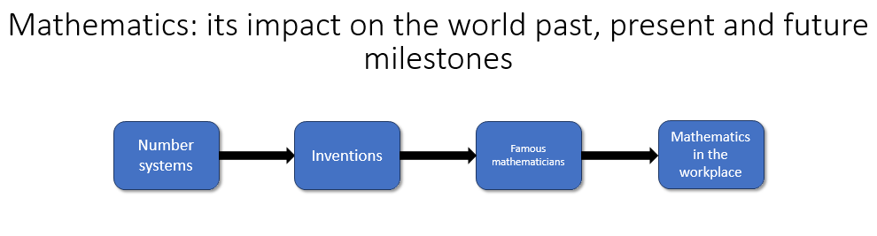

Significant aspect of learning:
Applying numeracy and mathematical skills
It is important that learners develop numeracy and mathematical skills as they build their knowledge and understanding. As learners progress, they should demonstrate an increasing sophistication in their ability to:
• interpret questions
• select and communicate processes and solutions
• justify choice of strategy used
• link mathematical concepts
• use mathematical vocabulary and notation
• use mental agility
• reason algebraically
• determine the reasonableness of a solution
These skills should be evident across the other significant aspects of learning in Numeracy and Mathematics. Staff should actively promote the development of these skills and ensure they are embedded in planning for learning, teaching and assessment.

Mathematics – its impact on the world, past present and future |  | Significant aspect of learning:  Use knowledge and understanding of the number system, patterns and relationships
 | Milestone | At the beginning of First Level | During First Level |  | By the end of First Level
I have discussed the important part that numbers play in the world and explored a variety of systems that have been used by civilisations throughout history to record numbers.  MTH 1-12a | Number systems | - I have explored some of the earliest number systems e.g. “bundle of sticks” and Egyptian number systems. | - I have explored number systems used by the Greeks, Romans, Indians and from Arabic countries. |  | - I have explored the binary number system and understand its importance in modern technology.
 | Milestone | At the beginning of Second Level | During Second Level |  | By the end of Second Level
I have worked with others to explore, and present our findings on, how mathematics impacts on the world and the important part it has played in advances and inventions.  MTH 2-12a | Inventions | - I have worked with others to research how mathematics has played a part in inventions, for example the wheel, map of the world. | I have worked with others to research how mathematics has played a part in advances in society. For example measuring time, code breaking. |  | - I can present my findings on the part mathematics has played in advances and inventions, using appropriate technology.
 | Milestone | During Third Level |  | By the end of Third Level
I have worked with others to research a famous mathematician and the work they are known for, or investigated a mathematical topic, and have prepared and delivered a short presentation.  MTH 3-12a | Famous mathematicians | - I have worked with others to research famous mathematicians and the work they were known for e.g. Archimedes, Emmy Noether. |  | - I have worked with others to research famous mathematicians and can deliver a presentation on the topic using appropriate technology.
 | Milestone | During Fourth Level |  | By the end of Fourth Level
I have discussed the importance of mathematics in the real world, investigated the mathematical skills required for different career paths and delivered, with others, a presentation on how mathematics can be applied in the workplace.  MTH 4-12a | Mathematics in the workplace | - I have worked with others to investigate the role mathematics plays in the workplace. |  | - I have worked with others to investigate the role mathematics plays in the workplace and can deliver, with others, a presentation using appropriate technology.

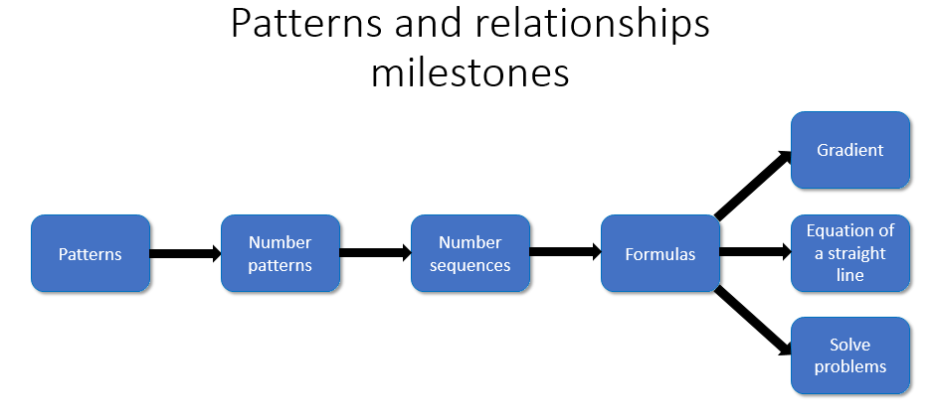
Significant aspect of learning:
Applying numeracy and mathematical skills
It is important that learners develop numeracy and mathematical skills as they build their knowledge and understanding. As learners progress, they should demonstrate an increasing sophistication in their ability to:
• interpret questions
• select and communicate processes and solutions
• justify choice of strategy used
• link mathematical concepts
• use mathematical vocabulary and notation
• use mental agility
• reason algebraically
• determine the reasonableness of a solution
These skills should be evident across the other significant aspects of learning in Numeracy and Mathematics. Staff should actively promote the development of these skills and ensure they are embedded in planning for learning, teaching and assessment.

Patterns and relationships |  | Significant aspect of learning:  Use knowledge and understanding of the number system, patterns and relationships
 | Milestone | During Early Level |  | By the end of Early Level
I have spotted and explored patterns in my own and the wider environment and can copy and continue these and create my own patterns.  MTH 0-13a | Patterns | - I can recognize simple numeric and non-numeric patterns.  - I can use simple language such as repeat, again, pattern etc. to describe these patterns. |  | - I can duplicate and extend a simple pattern.  - I can create my own patterns.
 | Milestone | At the beginning of First Level | During First Level |  | By the end of First Level
I can continue and devise more involved repeating patterns or designs, using a variety of media.  MTH 1-13a | Patterns | - I can recognise, duplicate and extend non-numeric patterns. | - I can explain the rules for repeating patterns. |  | - I can create a pattern of my own design and explain the rule for generating the sequence.
 | Number patterns | - I can recognise, duplicate and extend numeric patterns. | - I can explain the rules for number patterns. |  | - I can create a number pattern of my own design and explain the rule for generating the sequence.
Through exploring number patterns, I can recognise and continue simple number sequences and can explain the rule I have applied.  MTH 1-13b | Number sequences | - I can recognise and continue simple number sequences. | - I can describe how a sequence continues. |  | - I recognise when a sequence is ambiguous and check my own patterns to ensure they are not.
 | Milestone | At the beginning of Second Level | During Second Level |  | By the end of Second Level
Having explored more complex number sequences, including well-known named number patterns, I can explain the rule used to generate the sequence, and apply it to extend the pattern.  MTH 2-13a | Number sequences | - For number patterns involving the four operations, I can identify the pattern and extend the sequence. | - I can write a rule for a sequence, stating the start number and operation e.g. start and 2 and add on 3 or start at 3 and keep doubling. |  | - I have explored number sequences such as the Fibonacci sequence or triangular numbers and can explain the rule for these sequences.  - I can use a function machine to generate a number sequence.
 | Milestone | During Third Level |  | By the end of Third Level
Having explored number sequences, I can establish the set of numbers generated by a given rule and determine a rule for a given sequence, expressing it using appropriate notation.  MTH 3-13a | Formulas | - I can convert a pattern into a sequence of numbers and use a table to help me analyse the sequence of numbers.  - I can recognise relationships between successive terms and use this to write a rule for a sequence of numbers. |  | - I can write the rule using appropriate notation.  - I can use a rule for a sequence to predict the value of any given element in the pattern.  - I have investigated simple sequences that involve whole number powers.
 | Milestone | During Fourth Level |  | By the end of Fourth Level
Having explored how real-life situations can be modelled by number patterns, I can establish a number sequence to represent a physical or pictorial pattern, determine a general formula to describe the sequence, then use it to make evaluations and solve related problems.  MTH 4-13a | Formulas | - I can model real life situations using number patterns and graphs.  - I can determine a general formula to describe the sequence. |  | - I can use the general formulae to find missing terms and solve problems related to the pattern.
 | Solve problems
I have discussed ways to describe the slope of a line, can interpret the definition of gradient and can use it to make relevant calculations, interpreting my answer for the context of the problem.  MTH 4-13b | Gradient | - I understand the concept of slope in context. |  | - I can find the gradient for a straight line. I understand positive and negative gradients and the gradient of horizontal and vertical lines.
Having investigated the pattern of the coordinate points lying on a horizontal or vertical line, I can describe the pattern using a simple equation.  MTH 4-13c  I can use a given formula to generate points lying on a straight line, plot them to create a graphical representation then use this to answer related questions.  MTH 4-13d | Equation of a straight line | - I understand the link between the gradient of a straight line and the formula that generates the points on that line. |  | - I can use a formula to create a graph and interpret the gradient to solve problems in context.

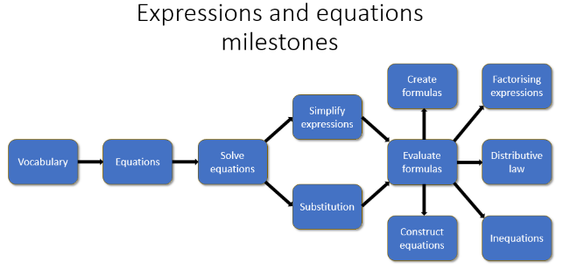
Significant aspect of learning:
Applying numeracy and mathematical skills
It is important that learners develop numeracy and mathematical skills as they build their knowledge and understanding. As learners progress, they should demonstrate an increasing sophistication in their ability to:
• interpret questions
• select and communicate processes and solutions
• justify choice of strategy used
• link mathematical concepts
• use mathematical vocabulary and notation
• use mental agility
• reason algebraically
• determine the reasonableness of a solution
These skills should be evident across the other significant aspects of learning in Numeracy and Mathematics. Staff should actively promote the development of these skills and ensure they are embedded in planning for learning, teaching and assessment.

Expressions and equations |  |  | Significant aspect of learning:  Use knowledge and understanding of the number system, patterns and relationships
 | Milestone | At the beginning of First Level |  | During First Level |  | By the end of First Level
I can compare, describe and show number relationships, using appropriate vocabulary and the symbols for equals, not equal to, less than and greater than.  MTH 1-15a | Vocabulary | - I understand that the = sign signifies balance in a number sentence. |  | - I can use the ≠ sign in a number sentence or to compare quantities. |  | - I can use the inequalities signs in a number sentence or to compare quantities.
When a picture or symbol is used to replace a number in a number statement, I can find its value using my knowledge of number facts and explain my thinking to others.  MTH 1-15b | Equations | - I understand that a picture or symbol can represent a number or sign in an equation. |  | - I can calculate the value of a missing number from an equation involving addition and subtraction. |  | - I can solve a missing number problem using my knowledge of number facts.
 | Milestone | At the beginning of Second Level |  | During Second Level |  | By the end of Second Level
I can apply my knowledge of number facts to solve problems where an unknown value is represented by a symbol or letter.  MTH 2-15a | Solve equations | - I have explored the concept of a variable in a range of contexts.  - I can solve missing number problems using inverses. |  | - I can describe what a variable is.  - I can form and solve simple equations. |  | - I can investigate variables by substituting into and evaluating formulae.  - I can solve simple inequalities.
 | Milestone | During Third Level |  |  | By the end of Third Level
I can collect like algebraic terms, simplify expressions and evaluate using substitution.  MTH 3-14a | Simplify expressions | - I can collect like terms to simplify an expression for additive terms. |  |  | - I can collect like terms to simplify an expression for both additive and multiplicative terms.  - I can create an expression to represent a situation and simplify it by collecting like terms.
 | Substitution | - I can substitute to evaluate expressions for additive terms. |  |  | - I can substitute to evaluate expressions for additive and multiplicative terms.  - I can evaluate expressions that include powers.
Having discussed ways to express problems or statements using mathematical language, I can construct, and use appropriate methods to solve, a range of simple equations.  MTH 3-15a | Construct equations | - I can solve an equation using inverses and by balancing. |  |  | - I can construct and then solve a range of linear equations using an appropriate method.
I can create and evaluate a simple formula representing information contained in a diagram, problem or statement.  MTH 3-15b | Create formulas | - I can complete tables using information from patterns. |  |  | - I can create a simple formula representing information contained in a diagram, problem or statement.
 | Evaluate formulas | - I can substitute to evaluate formulae for additive terms. |  |  | - I can substitute to evaluate formulae for additive and multiplicative terms.  - I can evaluate formulae that include powers.
 | Milestone | During Fourth Level |  |  | By the end of Fourth Level
Having explored the distributive law in practical contexts, I can simplify, multiply and evaluate simple algebraic terms involving a bracket.  MTH 4-14a | Distributive law | - I have explored the distributive law in practical contexts. |  |  | - I can simplify, multiply and evaluate simple algebraic terms involving brackets.  - I can use the distributive law to solve equations.
I can find the factors of algebraic terms, use my understanding to identify common factors and apply this to factorise expressions.  MTH 4-14b | Factorising expressions | - I can find the factors of algebraic terms. |  |  | - I can factorise simple expressions by taking out a common factor.  - I can use factorising to solve equations.
Having discussed the benefits of using mathematics to model real-life situations, I can construct and solve inequalities and an extended range of equations.  MTH 4-15a | Inequations | - I have explored how to use mathematics to model real life situations. |  |  | - I can construct and solve inequalities and an extended range of equations that represent real life situations.

Using knowledge and understanding of the number system, patterns and relationships

Benchmarks

What are the essential indicators of “good” … Use knowledge and understanding of the number system, patterns and relationships
What are the essential indicators of “good” … | P1 Benchmarks  By the end of P1 …
Number and number processes  Learners should be able … | - understand that zero means there is none  - subitise regular and irregular spot patterns  - count given collections accurately  - compare 2 collections 1:1 and decide which is bigger / smaller and by how many more / less  - Identify and represent all numbers at least to 20 (including zero) using numerals, words, symbols, pictures and objects  - count on and count back from a given number  - identify the number before / after / between a given number/s 0-20  - count in multiples of 2, 5 10  - solve addition and subtraction problems at least within 10  - know the facts for numbers families within 10  - know doubles within 10  - understand that when adding / subtracting zero the number stays the same  - share groups of objects
Estimation and rounding  Learners should be able … | - count the objects to decide which has the most or least  - sort and create groups of objects by number and describe their position first, second, third…
Fractions, Decimal fractions and percentages  Learners should be able … | - split a whole object into equal parts  - share out a group of items equally  - partition groups into 2, 4 or 8 parts and use associated vocabulary
Money  Learners should be able … | - know that coins/money can be exchanged for goods and services  - recognise the value of all coins  - use 1p, 2p, 5p coins to make monetary values  - use coins in real life contexts

What are the essential indicators of “good” … Use knowledge and understanding of the number system, patterns and relationship
What are the essential indicators of “good” … | P2 Benchmarks | P3 Benchmarks | P4 Benchmarks
Number and number processes  Learners should be able … | - count on and back to solve number problems  - add by counting from the biggest number  - identify the number before and after a given number in the range 0-100  - recite number sequences from a given number  - know zero is a place holder  - identify the value of the digits in a numeral to at least 100  - know basic facts for addition and subtraction and number families to 20  - recall the facts from 2 times table  - use repeated addition and subtraction to solve multiplication and division problems  - know when we divide by 2 we share between 2 using our knowledge of the 2 times table | - identify the number before and after a given number beyond 100  - construct 2 digit numbers  - know basic facts for addition and subtraction and number families to 100  - use doubles, halves and similar strategies to add and subtract numbers  - recall facts from the 3, 4, 5, 10 times tables (multiplication and division)  - use jumps groups and sharing to solve multiplication problems | - count on and back in tens from a given whole number  - identify the number before and after any given number in the range 0-1000  - build, describe and count arrays of numbers  - put 2 digit numbers in order  - identify the value of the digits in a numeral to at least 1000  - solve a variety of addition and subtraction tasks using 3 digit numbers  - write a number sentence that follows the sense of a story problem  - use a range mental strategies to solve problems  - recall facts from the 6, 7, 8, 9 times tables (multiplication and division)  - use jumps, groups and sharing to solve multiplication and division problems
Estimation and rounding  Learners should be able … | - estimate quantities to 10  - estimate answer to 2 digit addition and subtractions by rounding  - round numbers to the nearest ten | - estimate quantities to 20  - estimate answer to 3 digit addition and subtractions by rounding  - round numbers to the nearest 100 | - estimate quantities to 100  - compare an estimation with the answer to a calculation and decide if the answer is reasonable  - round numbers to the nearest 1000
Fractions, Decimal fractions and percentages  Learners should be able … | - share a group of items equally  - share a single item equally and use the associated vocabulary  - know what denominator and numerator mean  - find the fraction of an amount using concrete materials  - demonstrate equivalent fractions using materials | - divide an object into halves, quarters and eighths  - use vocabulary of fractions  - compare simple fractions  - draw pictures to show fractions that are equivalent | - understand that a fraction is an equal part of a whole  - read and write fractions using fraction notation  - understand that a comparison can be made between fractions with the same denominator  - find the fraction of an amount using division
Money  Learners should be able … | - recognise notes and coins  - read and write monetary values in pence  - count money and keep a track of how much I have  - use notes and coins to make up monetary values | - read and write monetary values, including using the appropriate symbols  - calculate change | - read and write monetary values using correct notation including the decimal point  - demonstrate the most efficient way to give change
What are the essential indicators of “good” … Use knowledge and understanding of the number system, patterns and relationships
What are the essential indicators of “good” … | P5 Benchmarks | P6 Benchmarks | P7 Benchmarks
Number and number processes  Learners should be able … | - use column addition and subtraction when it is appropriate  - multiply by common multiples of 10 (20, 30, 40)  - understand that when we divide within the times tables we share using our knowledge of the times tables  - know that in multiple calculations (e.g. 2+3×4 ) multiplication / division should precede addition/subtraction  - understand that addition is commutative (5+3 = 3+5 etc)  - understand that addition is associative (3+4+5 =(3+4)+5) and can use this to solve a problem by grouping numbers  - understand the distributive law and can split numbers to solve multiplication calculations outwith the times tables e.g. 5x15=5x10+5x5  - explain what negative numbers are and when they might be used  - use place value to partition numbers | - recall all the multiplication /division facts from memory  - apply the order of operations to problems involving x, ÷, +, -  - use the commutative property of addition to solve a problem by changing the order of the numbers  - use the associative property of addition to solve a problem by grouping numbers  - construct a number line to answer questions that involve negative numbers  - understand place value of decimal numbers | - demonstrate a range of mental strategies to solve problems with whole numbers  - multiply and divide by common multiples of 10 and powers of 10  - perform short multiplication and division by a single digit number  - apply the order of operations to problems involving brackets and indices  - understand that multiplication is commutative and can use this to solve a problem by changing the order of the factors  - understand that multiplication is associative and can use this to solve a problem by grouping numbers  - solve problems involving negative numbers mentally  - use negative numbers in everyday contexts and familiar applications  - explain how zero is used as a place holder for whole numbers and decimals  - demonstrate a range of mental strategies that I can use to solve problems with whole numbers, decimals and fractions
Estimation and rounding  Learners should be able … | - round numbers to the nearest unit  - understand how rounded numbers can be used to estimate | - round numbers to 1 decimal place  - use rounded numbers to estimate | - round numbers to 2 decimal places  - round numbers to estimate and check answers
Fractions, Decimal fractions and percentages  Learners should be able … | - add/subtract decimal fractions with 1 decimal place  - multiply/divide decimal fractions with 1 decimal place by a whole number  - multiply/divide decimal fractions by 10  - find the fraction of an amount by using concrete materials e.g. $\frac{2}{3}of 15$  - know what a mixed number is  - know what an improper fraction is  - understand that a percentage is a fraction with a denominator of 10  - calculate with 25%, 50% and 100%  - find equivalent fractions using multiplication and division  - solve simple problems using fractions and decimal fractions  - show where simple fractions and decimal fractions lie on a number line | - add/subtract decimal fractions with 2 decimal places  - multiply/divide decimal fractions with 2 decimal places by a whole number  - multiply/divide decimal fractions by 100  - find the fraction of an amount by using pictures or informal jottings e.g. $\frac{2}{3}of 15$  - convert an improper fraction to a mixed number  - carry out calculations with 1%, 10%, 20%, 25%, 50%, 75% and 100%  - use equivalent fractions to compare the size of commonly used fractions and put them in order  - show the equivalence between fractions, decimal fractions and percentages using counters or a picture | - add/subtract decimal fractions with 3 decimal places  - multiply/divide decimal fractions with 3 decimal places by a whole number  - multiply/divide decimal fractions by 1000  - find the fraction of an amount by using multiplication and division e.g. $\frac{2}{3}of 15$  - convert between mixed numbers and improper fractions  - carry out calculations with any percentage  - reduce fractions to the simplest form  - convert between simple fractions, decimal fractions and percentages  - calculate with simple fractions, decimal fractions and percentages to solve problems in everyday contexts, choose my preferred form and explain my choices  - show where any fraction, decimal fraction or percentage lies on a number line
Money  Learners should be able … | - calculate the cost of an item or selection of items  - add and subtract monetary values with a decimal point  - understand the terms profit and loss  - plan purchases within a given budget | - calculate the money left over after paying for an item or selection of items  - use decimals in the context of money  - use written and mental calculation strategies to +,-,x and ÷ with money  - understand profit and loss in buying and selling activities  - find the cost of the same or similar items/services from a range of retailers to find the best value  - plan purchases, making appropriate decisions within given budgeting constraints | - compare the price of goods against a given budget and determine if they are affordable  - solve real life problems involving money  - use decimals and negative numbers in the context of money  - talk about profit and loss in buying and selling activities and make calculations for this  - calculate discounts  - use budgeting skills to make responsible spending decisions  - use the vocabulary associated with personal banking and understand the use of bank cards

Using knowledge and understanding of measurement and its application

Progression

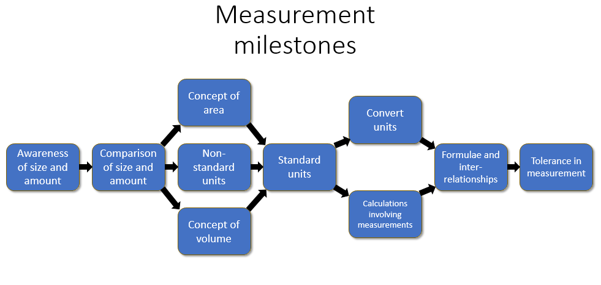
Significant aspect of learning:
Applying numeracy and mathematical skills
It is important that learners develop numeracy and mathematical skills as they build their knowledge and understanding. As learners progress, they should demonstrate an increasing sophistication in their ability to:
• interpret questions
• select and communicate processes and solutions
• justify choice of strategy used
• link mathematical concepts
• use mathematical vocabulary and notation
• use mental agility
• reason algebraically
• determine the reasonableness of a solution
These skills should be evident across the other significant aspects of learning in Numeracy and Mathematics. Staff should actively promote the development of these skills and ensure they are embedded in planning for learning, teaching and assessment.
Measurement |  |  | Significant aspect of learning:  Use knowledge and understanding of measurement and its application
 | Milestone | During Early Level |  |  | By the end of Early Level
I have experimented with everyday items as units of measure to investigate and compare sizes and amounts in my environment, sharing my findings with others.  MNU 0-11a | Awareness of size  and amount | - I am beginning to use language such as tall, short, fat, thin, heavy, light, wide, big or small. |  |  | - I can use familiar objects to measure the length, weight or capacity of items to help me compare them e.g. how many marbles fit in a jar or how many cups in a jug of water or the number of hands across a table.
 | Comparison of size and amount  - Ordering  - Conservation of size, weight and volume | - I am beginning to use comparative language to describe the attributes of familiar items e.g. bigger/smaller, taller/shorter.  - I can compare two objects by comparing their length, weight or capacity. |  |  | - I use descriptive language such as tall, short, fat, thin, heavy, light, wide, big or small.  - I can put objects in order or length, weight or capacity by comparing them directly.
 | Milestone | At the beginning of First Level |  | During First Level |  | By the end of First Level
I can estimate how long or heavy an object is, or what amount it holds, using everyday things as a guide, then measure or weigh it using appropriate instruments and units.  MNU 1-11a | Comparison of size and amount  - Ordering  - Conservation of size, weight and volume | - I understand that the length of a shape does not change when moved or reshaped. |  | - I know that the weight/volume/length of an object/liquid cannot change even when moved or reshaped. |  | - I know that the weight/volume/length of an object/liquid remains the same even when measured using different units (e.g. feet vs metres, kg vs stones, ml vs pints).
 | Concept of volume  - Units of volume  - Estimating volume  - Capacity | - I can compare the size of two objects by using a third object (e.g. arm lengths or a piece of string).  - I have explored the concept of volume using familiar items.  - I am beginning to estimate the volume of an item, using the language of non-standard units, by comparing it to something I already know the volume of. |  | - I can use non-standard units of measurement to compare the volume of two objects.  - When I measure volume I take care to measure accurately (e.g. I try not to spill when measuring). |  | - I can use standard units of measurement to compare objects. I use the correct language for naming each unit as well as the correct conventions and symbols for writing them.  - I can justify my estimates of the volume of an item, using the language of standard units, by comparing it to something I already know the volume of.
I can estimate the area of a shape by counting squares or other methods.  MNU 1-11b | Concept of area  - Understanding area  - Estimating area  Units of area | - I have explored the concept of area using familiar items.  - I can compare areas by putting one item onto another item.  - I can use non-standard units of measurement to measure area. |  | - I can estimate the area of regular and irregular shapes using a shape template, counting squares or similar method.  - I can estimate the area of regular shapes by drawing around shape templates and counting the total. |  | - I can justify my estimates of the area by comparing them to familiar objects.  - I know that the area of a shape cannot change even when moved or reshaped.  - I can estimate the area of an item using the language of standard units by comparing it to something I already know the area of.  - I can use standard units of measurement to measure area and use the correct language for naming each unit and the correct symbols for writing them.
 | Milestone | At the beginning of Second Level |  | During Second Level |  | By the end of Second Level
I can use my knowledge of the sizes of familiar objects or places to assist me when making an estimate of measure.  MNU 2-11a | Non-standard units | - I need help to choose the best way to measure an item.  - When I measure an item I sometimes leave gaps or overlap my units and do not worry about spills when measuring capacity. |  | - I know that the unit must not change during the measuring activity (i.e. if I am using pictures of feet they must all be the same size or I must use the same picture repeatedly).  - I can choose an appropriate unit of measurement (e.g. to measure a pencil I use fingers, not feet) to compare items. |  | - I can choose an appropriate unit of measurement to use and compare items.  - When I measure I take care to measure accurately.
I can use the common units of measure, convert between related units of the metric system and carry out calculations when solving problems.  MNU 2-11b | Standard units  - Measure using standard units  - Inter-relationship between units of measurement  - Link between concept and formula of area | - I am beginning to choose when it is best to estimate and when to measure.  - I know the relationship between some of the standard units of measure e.g. 10mm=1cm.  - I know the standard units of measure. |  | - I know the relationship between some of the standard units of measure e.g. 10mm=1cm, 100cm=1m.  - I can use standard units of measurement and choose which unit to use. |  | - I know when it is appropriate to estimate and when to measure.  - I can use standard units of measurement and justify my choice of unit.  - I can justify my estimates by drawing on my experiences with the length, mass or capacity of everyday objects and explain how confident I am of my estimates.  - I know the relationship between the standard units of measure e.g. 10mm=1cm, 100cm=1m, 1000cm³=1l.
 | Convert units | - I can convert between some of the related units of the metric system e.g. converting between cm and mm. |  | - I can convert between convert between the units of length mm, cm, m, km. |  | - I can convert between related units of the metric system.
I can explain how different methods can be used to find the perimeter and area of a simple 2D shape or volume of a simple 3D object.  MNU 2-11c | Calculations involving measurement  - Select the most appropriate calculation dependant on the situation and context | - I can calculate the area, perimeter and volume of simple shapes. |  | - When I am solving problems I can choose the attribute and units to suit the situation.  - I can explain how different methods can be used to find the perimeter of a shape. |  | - I use a problem solving process, a range of problem solving strategies and appropriate calculation methods when I solve measurement problems.  - I can explain how different methods can be used to find the area of a simple shape.  - I can explain how different methods can be used to find the volume of a simple 3D shape.

 | Milestone | During Third Level | By the end of Third Level
I can solve practical problems by applying my knowledge of measure, choosing the appropriate units and degree of accuracy for the task and using a formula to calculate area or volume when required.  MNU 3-11a  Having investigated different routes to a solution, I can find the area of compound 2D shapes and the volume of compound 3D objects, applying my knowledge to solve practical problems.  MTH 3-11b | Formulae and inter-relationships | - I can detect unrealistic estimates or measurements.  - I ensure the units are consistent across the problem by converting between metric units.  - I can choose the degree of accuracy (decimal places) to work with by considering the information given or instrument used.  - I can calculate area and volume using an array.  - I can break a compound shape into smaller parts to find its area. I can detect unrealistic estimates or measurements, justifying my reasons and suggesting alternatives.  - I choose appropriate units and ensure that the units are consistent across the problem.  - I can choose the appropriate degree of accuracy (sig figs) to work with by considering the information given or instrument used.  - I can calculate area and volume using a formula.  - I can find the area and volume of compound shapes to solve practical problems. | - I can detect unrealistic estimates or measurements, justifying my reasons and suggesting alternatives.  - I choose appropriate units and ensure that the units are consistent across the problem.  - I can choose the appropriate degree of accuracy (sig figs) to work with by considering the information given or instrument used.  - I can calculate area and volume using a formula.  - I can find the area and volume of compound shapes to solve practical problems.
 | Milestone | During Fourth Level | By the end of Fourth Level
I can apply my knowledge and understanding of measure to everyday problems and tasks and appreciate the practical importance of accuracy when making calculations.  MNU 4-11a | Formulae and inter-relationships | - I can apply my knowledge and understanding of measure to a limited range of problems and tasks. | - I can apply my knowledge and understanding of measure to a wide range of everyday problems and tasks.  - I consider the practical importance of accuracy when making calculations.
 | Tolerance in measurement | - I know what is meant by tolerance.  - I can write tolerances in the form 200cm± 2cm. | - I can interpret tolerances e.g. 200cm ± 2cm.  - I know that rounding numbers inappropriately in a calculation will lead to an insufficiently accurate answer.  - I can analyse a problem and choose an appropriate degree of accuracy for rounding.

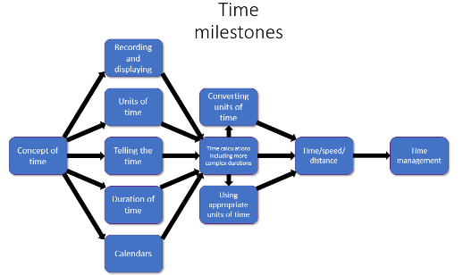
Significant aspect of learning:
Applying numeracy and mathematical skills
It is important that learners develop numeracy and mathematical skills as they build their knowledge and understanding. As learners progress, they should demonstrate an increasing sophistication in their ability to:
• interpret questions
• select and communicate processes and solutions
• justify choice of strategy used
• link mathematical concepts
• use mathematical vocabulary and notation
• use mental agility
• reason algebraically
• determine the reasonableness of a solution
These skills should be evident across the other significant aspects of learning in Numeracy and Mathematics. Staff should actively promote the development of these skills and ensure they are embedded in planning for learning, teaching and assessment.
Time |  | Significant aspect of learning:  Use knowledge and understanding of measurement and its application
 | Milestone | During Early Level |  | By the end of Early Level
I am aware of how routines and events in my world link with times and seasons, and have explored ways to record and display these using clocks, calendars and other methods.  MNU 0-10a | Concept of time | - I can use the names of the days of the week.  - I can describe the seasons and the special events associated with them.  - I can use a weekly planner.  - I know that an event has duration but cannot yet use a timer.  - I can tell the time to whole hours. |  | - I know the names and sequence of the days of the week and can plan events for future weeks.  - I can describe the seasons and their order through the year.  - I can use a calendar to plan or record an event.  - I can use non-standard units to measure the duration of an event.  - I can read time to ½ or ¼ of an hour.
 | Milestone | At the beginning of First Level | During First Level |  | By the end of First Level
I can tell the time using 12 hour clocks, realising there is a link with 24 hour notation, explain how it impacts on my daily routine and ensure that I am organised and ready for events throughout my day.  MNU 1-10a | Recording and displaying | - I can record the time using 12 hour notation. | - I can record the time using 12 and 24 hour notation. |  | - I can record the time using both 12 and 24 hour notation from analogue and digital clocks.
 | Telling the time  Analogue and digital | - I can tell the time using 12 hour notation.  - I can show time on an analogue clock, demonstrating the position of the hour and minute hands for on the hour. | - I can tell the time using 12 and 24 hour notation.  - I can show time on an analogue clock, demonstrating the relative position of the hour and minute hand for half past and quarter past the hour. |  | - I can tell the time using both 12 and 24 hour notation from analogue and digital clocks.  - I can show time on an analogue clock, demonstrating the relative position of the hour and minute hand.
I have begun to develop a sense of how long tasks take by measuring the time taken to complete a range of activities using a variety of timers.  MNU 1-10c | Units of time  - Relationships  - Appropriate use | - I can use the vocabulary associated with clocks.  - I know how many seconds there are in a minute.  - I know how many days there are in a year. | - I know how many seconds there are in a minute and how many minutes in an hour.  - I am beginning to learn the number of days in each month.  - I can use some units of time appropriately in familiar experiences. |  | - I can use the vocabulary associated with clocks and calendars.  - I know how many seconds there are in a minute, minutes in an hour and hours in a day.  - I know how many days there are in each month.  - I can use seconds, minutes, hours, days, months and years appropriately in familiar experiences e.g. How long does it take to drive to Aberdeen?
 | Duration of time  - Timing of tasks  - Simple timetables  - Estimating duration | - I can use a variety of timers to measure events using minutes.  - I can use non-standard units of time to measure the duration of events and use these to estimate in minutes. | - I can use a variety of timers to measure events using minutes and seconds.  - I can use non-standard units of time to measure the duration of events and use these to estimate minutes and seconds. |  | - I can use a variety of timers to measure events using hours, minutes and seconds.  - I can use non-standard units of time to measure the duration of events and use these to estimate hours, minutes and seconds.

I can use a calendar to plan and be organised for key events for myself and my class throughout the year.  MNU 1-10b | Calendars | - I can plan events over the course of a week or month. | - I can use a calendar to plan events. | - I can use a calendar to plan events for myself and others.
 | Milestone | At the beginning of Second Level | During Second Level | By the end of Second Level
I can use and interpret electronic and paper-based timetables and schedules to plan events and activities, and make time calculations as part of my planning.  MNU 2-10a | Duration of time  - Timing of tasks  - Simple timetables  - Estimating duration | - I can plan a journey given a limited number of times presented in 12 hour notation. | - I can read timetables using 12 hour time to plan a journey. | - I can apply my knowledge of 12 and 24 hour notation to plan a journey using timetables.
Using simple time periods, I can give a good estimate of how long a journey should take, based on my knowledge of the link between time, speed and distance.  MNU 2-10c | Converting units of time | - I can convert a number of seconds into minutes and seconds. | - I can convert a number of minutes into hours and minutes. | - I can convert between minutes, seconds, hours and days.
 | Time calculations including more complex durations  - Calendars and timetables  - Journey times | - If I know the start time and duration of an event (e.g. journey, movie) I can calculate when it ends (within the hour).  - I can use a calendar to calculate the number of days between events within the month.  - I can calculate time intervals from timetables in 12 hour notation, both mentally and using a written format.  - I can calculate the length of a journey within the hour if I know the start and finish times. | - If I know the start time and duration of an event (e.g. journey, movie) I can calculate when it ends. (bridging across the hour).  - I can use a calendar to calculate the number of days between events over a few weeks bridging over the months. | - If I know the end time and duration of an event, I can calculate when it started.  - I can estimate the time taken for a journey given the speed and distance for easy values e.g. If I a car travels 100km at 50kph how long does the journey take?  - I can use a calendar to calculate the number of days between events.  - I can calculate time intervals from timetables both mentally and using a written format.  - I can calculate the length of a journey across the hour if I know the start and finish times.
I can carry out practical tasks and investigations involving timed events and can explain which unit of time would be most appropriate to use.  MNU 2-10b | Using appropriate units of time | - I am beginning to use timing devices to time practical activities. | - I can time practical activities. | - I can time practical activities and justify my choice of unit.

 | Milestone | During Third Level | By the end of Third Level
Using simple time periods, I can work out how long a journey will take, the speed travelled at or distance covered, using my knowledge of the link between time, speed and distance.  MNU 3-10a | Time/Speed/ Distance  - Estimation in relation to time/speed/ distance  - Calculations  - Graphs | - I can use the formula for calculating speed.  - I can determine approximate speed, distance and time for a journey for easy values.  - I can calculate or measure time intervals.  - I can interpret distance/time graphs and timelines for simple time periods. | - I can use the link between speed, distance and time to calculate an unknown (whole numbers only).  - I can apply my knowledge of the relationship between speed, distance and time to determine an approximate speed, distance or time for a journey.  - I can calculate or measure time intervals and use this in a speed or distance calculation.  - I can display and interpret solutions using graphs and timelines.
 | Milestone | During Fourth Level | By the end of Fourth Level
I can use the link between time, speed and distance to carry out related calculations.  MNU 4-10b | Time/Speed/ Distance  - Estimation in relation to time/speed/ distance  - Calculations  - Graphs | - I can use the link between speed, distance and time to calculate an unknown, including fractions and decimal fractions of time.  - I can convert time into fractions and decimal fractions of time for ½ or ¼ of an hour. | - I can use the link between speed, distance and time to calculate an unknown, including fractions and decimal fractions of time and where the units need to be converted.  - I can convert time into fractions and decimal fractions of time.
I can research, compare and contrast aspects of time and time management as they impact on me.  MNU 4-10a | Time management | - I have a limited range of research and problem solving skills that I use to solve real life time activities.  - I can find the solution to time problems.  - I can interpret graphs and timelines. | - I have a range of research and problem solving skills that I use to solve real life time problems.  - I can interpret the solutions to time problems and relate to the personal impact of these solutions.  - I can display and interpret solutions using graphs and timelines.

Using knowledge and understanding of measurement and its application

Benchmarks

What are the essential indicators of “good” … Use knowledge and understanding of measurement and its application
What are the essential indicators of “good” … | P1 Benchmarks  By the end of P1 …
Measurement  Learners should be able … | - use objects to measure the length, weight or capacity of items to help me compare them  - use vocabulary tall, short, fat, thin, heavy, light, wide, big or small  - put objects in order according to length, weight or capacity by comparing them directly
Time  Learners should be able … | - understand and use the terms before and after  - understand the sequence of morning, afternoon, evening and night  - know the names of and sequence the days of the week  - describe and order the seasons  - read time to o’clock and half past

What are the essential indicators of “good” … Use knowledge and understanding of measurement and its application
What are the essential indicators of “good” … | P2 Benchmarks | P3 Benchmarks | P4 Benchmarks
Measurement  Learners should be able … | - understand that the length of a shape does not change when moved or reshaped  - compare the size of two objects by using a third object (e.g. arm lengths or a piece of string)  - estimate the volume of an item using the language of non-standard units, by comparing it to something I already know the volume of  - compare areas by putting one item onto another item  - use non-standard units of measurement to measure area | - understand that the weight/volume/length of an object/liquid cannot change even when moved or reshaped  - use non-standard units to compare the volume of two objects  - estimate the area of regular and irregular shapes | - know that the weight/volume/length of an object/liquid remains the same even when measured using different units  - use standard units of measurement to compare objects  - use the correct language for naming each unit as well as the correct conventions and symbols for writing them  - justify my estimates of the volume of an item, using the language of standard units, by comparing it to something I already know the volume of  - justify my estimates of the area by comparing them to familiar objects  - know that the area of a shape cannot change even when moved or reshaped  - estimate the area of an item using the language of standard units by comparing it to something I already know the area of  - use standard units of measurement to measure area and use the correct language for naming each unit and the correct symbols for writing them
Time  Learners should be able … | - record the time using 12 hour notation  - tell the time using 12 hour notation  - on an analogue clock demonstrate the position of the hour and minute hands for on the hour  - use the vocabulary associated with clocks  - know how many seconds there are in a minute  - know how many days there are in a year  - know the months of the year  - use timers to measure events  - use non-standard units of time to measure the duration of events and use these to estimate in minutes  - plan events over the course of a week or month | - tell the time using 12 and 24 hour notation  - on an analogue clock demonstrate the relative position of the hour and minute hand for half past and quarter past the hour  - know how many seconds there are in a minute  - know how many minutes in an hour  - use a variety of timers to measure events using minutes and seconds  - use non-standard units of time to measure the duration of events and use these to estimate minutes and seconds | - record the time using both 12 and 24 hour notation from analogue and digital clocks  - tell the time using both 12 and 24 hour notation from analogue and digital clocks  - show time on an analogue clock, demonstrating the relative position of the hour and minute hand  - use the vocabulary associated with calendars  - know how many seconds there are in a minute, minutes in an hour and hours in a day  - know how many days there are in each month  - use seconds, minutes, hours, days, months and years appropriately in familiar experiences  - use timers to measure events using hours, minutes and seconds  - use non-standard units of time to measure the duration of events and use these to estimate hours, minutes and seconds  - use a calendar to plan events

What are the essential indicators of “good” … Use knowledge and understanding of measurement and its
What are the essential indicators of “good” … | P5 Benchmarks | P6 Benchmarks | P7 Benchmarks
Measurement  Learners should be able … | - choose the best way to measure an item  - know the standard units of measure  - know the relationship between some of the standard units of measure e.g. 10mm=1cm  - calculate the area, perimeter and volume of simple shapes | - know that the unit must not change during the measuring activity  - choose an appropriate unit of measurement to compare items  - use standard units of measurement and choose which unit to use  - convert between convert between the units of length mm, cm, m, km  - explain how different methods can be used to find the perimeter of a shape | - choose an appropriate unit of measurement to use and compare items  - measure accurately  - know when it is appropriate to estimate and when to measure  - use standard units of measurement and justify my choice  - justify my estimates  - know the relationship between the standard units of measure e.g. 10mm=1cm, 100cm=1m, 1000cm³=1l  - convert between related units of the metric system  - use a problem solving process, a range of problem solving strategies and appropriate calculation methods when I solve measurement problems  - explain how different methods can be used to find the area of a simple shape  - explain how different methods can be used to find the volume of a simple 3D shape
Time  Learners should be able … | - plan a journey given a limited number of times presented in 12 hour notation  - convert a number of seconds into minutes and seconds  - calculate the duration of a journey / event (within an hour)  - use a calendar to calculate the number of days between events within the month  - calculate time intervals from timetables in 12 hour notation  - use a timing device to time practical activities | - read timetables using 12 hour time to plan a journey  - convert a number of minutes into hours and minutes  - calculate when a journey or event ends bridging across the hour  - use a calendar to calculate the number of days between events over a few weeks bridging over the months | - apply knowledge of 12 and 24 hour notation to plan a journey using timetables  - convert between minutes, seconds, hours and days  - using the start time calculate the end time and duration of an event  - estimate the time taken for a journey given the speed and distance for given values  - given the start and finish times calculate the length of a journey across the hour  - use a calendar to calculate the number of days between events  - calculate time intervals from timetables both mentally and using a written format  - time practical activities and justify my choice of unit

Researching and evaluating data to assess risks and make informed choices

Progression

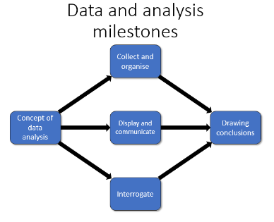
Significant aspect of learning:
Applying numeracy and mathematical skills
It is important that learners develop numeracy and mathematical skills as they build their knowledge and understanding. As learners progress, they should demonstrate an increasing sophistication in their ability to:
• interpret questions
• select and communicate processes and solutions
• justify choice of strategy used
• link mathematical concepts
• use mathematical vocabulary and notation
• use mental agility
• reason algebraically
• determine the reasonableness of a solution
These skills should be evident across the other significant aspects of learning in Numeracy and Mathematics. Staff should actively promote the development of these skills and ensure they are embedded in planning for learning, teaching and assessment.

Data and analysis |  | Significant aspect of learning:  Research and evaluate data to assess risks and make informed choices
 | Milestone | During Early Level |  | By the end of Early Level
I can use the signs and charts around me for information, helping me plan and make choices and decisions in my daily life.  MNU 0-20c | Concept of data analysis | - I can tell my teacher and peers what signs in my immediate environment mean. |  | - I gain information from simple displays e.g. how many dogs are there or what are the most common pets.
I can collect objects and ask questions to gather information, organising and displaying my findings in different ways.  MNU 0-20a  I can match objects, and sort using my own and others’ criteria, sharing my ideas with others.  MNU 0-20b | Collect and organise  - Matching, sorting and comparing  - Gathering and organising | - I can collect a group of objects to answer a question posed by me or someone else.  - I can sort my data into groups using simple criteria and explain how I did this.  - I can draw a picture to make a display of my findings. I can talk about my findings and what the display shows. |  | - I can use individual tally marks to collect information to answer a question posed by me or someone else.  - I can sort and group my objects or data using a range of criteria and explain my reasons for choosing this method.  - I can draw a pictograph or block graph to make a display of my findings and summarise the information in the display by counting.
 | Milestone | At the beginning of First Level | During First Level |  | By the end of First Level
I have used a range of ways to collect information and can sort it in a logical, organised and imaginative way using my own and others’ criteria.  MNU 1-20b | Collect and organise  - Matching, sorting and comparing  - Gathering and organising | - I can use a range of data collection methods designed by others. | - I am beginning to design my own data collection methods. |  | - I can design and use my own data collection methods.
Using technology and other methods, I can display data simply, clearly and accurately by creating tables, charts and diagrams, using simple labelling and scale.  MTH 1-21a | Display and communicate  - Types of display  - Communicating findings | - I can draw simple diagrams, tables and charts to display data I have collected. E.g. to create a pictograph I have equally sized pictures that I glue onto a poster. I write on labels and a title. | - I can draw simple diagrams tables and charts to display data I have collected. E.g. a bar chart with labels, frequency and a title. I can write a few sentences to describe the results of my data collection. |  | - I can draw simple diagrams, table and charts to display data I have collected using a graphing software package or simple spreadsheet. I can write a few sentences to describe the results of my data collection.
I have explored a variety of ways in which data is presented and can ask and answer questions about the information it contains.  MNU 1-20a | Interrogate  - Critical analysis of data | - I can read information from diagrams and tables (1-1 correspondence only).  - I can make simple predictions and collect information to test them. | - I can read information from diagrams and tables e.g. frequencies (one-one correspondence only) and describe the important features of the data represented e.g. say, “their graph tells me that most children asked had dogs as pets”.  - I can make predictions and collect information to test them. |  | - I can read information from diagrams and tables (1-1 correspondence only) and describe the important features of the data represented.  - I can assess the accuracy and appropriateness of diagrams.  - I can make predictions and collect information to test them using my own criteria.
 | Milestone | At the beginning of Second Level | During Second Level |  | By the end of Second Level
I have carried out investigations and surveys, devising and using a variety of methods to gather information and have worked with others to collate, organise and communicate the results in an appropriate way.  MNU 2-20b  I can display data in a clear way using a suitable scale, by choosing appropriately from an extended range of tables, charts, diagrams and graphs, making effective use of technology.  MTH 2-21a | Display and communicate  - Types of display  - Communicating findings | - I can suggest information to collect to answer particular questions.  - I can represent data, using suitable scales, from an extended range of tables, charts, diagrams, plots and graphs. | - I can clarify questions to decide what data to collect e.g. when collecting data about favourite fruit.  - I can represent data, using suitable scales, from an extended range of tables, charts, diagrams, plots and graphs. I can explain what the diagrams show. |  | - I can create my own categories when collecting data and explain what these should include and exclude.  - I can represent data by choosing from an extended range of tables, charts, diagrams, plots and graphs using a software package when appropriate. I can explain what the diagrams show.
Having discussed the variety of ways and range of media used to present data, I can interpret and draw conclusions from the information displayed, recognising that the presentation may be misleading.  MNU 2-20a | Interrogate  - Critical analysis of data | - I can check the data has been recorded accurately.  - I can read information from a range of tables, charts, diagrams, plots and graphs (including 1 to many correspondence). | - I can say if my data is accurate and helps me answer my questions or if I need to refine it.  - I can compare different displays of the same data by discussing the key features of each. |  | - I can reflect on the process of collection and say if any misleading or inaccurate data has been collected. I can redesign my data collection method to avoid these problems next time round.  - I can compare different displays of the same data. I can also explain why a presentation might be misleading.
 | Milestone | During Third Level |  | By the end of Third Level
I can work collaboratively, making appropriate use of technology, to source information presented in a range of ways, interpret what it conveys and discuss whether I believe the information to be robust, vague or misleading.  MNU 3-20a | Interrogate  - Critical analysis of data | - I can find information in text, numerical, pictorial form from a variety of sources. |  | - I can interpret, describe and discuss the important features of a data set and discuss whether I believe the information to be robust, vague or misleading.
When analysing information or collecting data of my own, I can use my understanding of how bias may arise and how sample size can affect precision, to ensure that the data allows for fair conclusions to be drawn.  MTH 3-20b | Drawing conclusions  - Readability and validity  - Bias and sample size  - Statistical calculation | - I can justify the sample size for my data collection and explain how bias may arise. |  | - When analysing information or collecting my own data I understand that bias may arise and the sample size can affect precision. I use this knowledge when I design my data collection process and when I justify my conclusions and predictions.
 | Milestone | During Fourth Level |  | By the end of Fourth Level
I can evaluate and interpret raw and graphical data using a variety of methods, comment on relationships I observe within the data and communicate my findings to others.  MNU 4-20a  In order to compare numerical information in real life contexts, I can find the mean, median, mode and range of sets of numbers, decide which type of average is most appropriate to use and discuss how using an alternative type of average could be misleading.  MTH 4-20b | Drawing conclusions  - Readability and validity  - Bias and sample size  - Statistical calculation | - I understand what is meant by average and can calculate the mode and median.  - I can use a limited range of methods to evaluate and interpret data. |  | - I can calculate the mean, median, mode and range of a data set and justify which average I use.  - I can use a variety of methods to evaluate and interpret data and comment on relationships I find in the data, communicating my findings clearly.

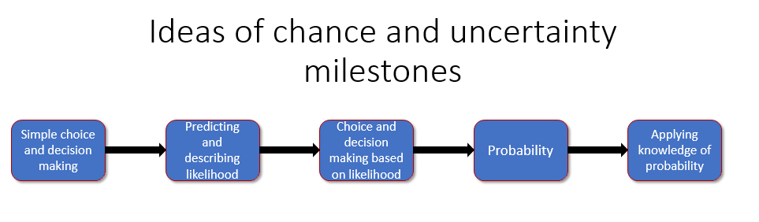

Significant aspect of learning:
Applying numeracy and mathematical skills
It is important that learners develop numeracy and mathematical skills as they build their knowledge and understanding. As learners progress, they should demonstrate an increasing sophistication in their ability to:
• interpret questions
• select and communicate processes and solutions
• justify choice of strategy used
• link mathematical concepts
• use mathematical vocabulary and notation
• use mental agility
• reason algebraically
• determine the reasonableness of a solution
These skills should be evident across the other significant aspects of learning in Numeracy and Mathematics. Staff should actively promote the development of these skills and ensure they are embedded in planning for learning, teaching and assessment.

Ideas of chance and uncertainty |  | Significant aspect of learning:  Research and evaluate data to assess risks and make informed choices
 | Milestone | At the beginning of First Level | During First Level | By the end of First Level
I can use appropriate vocabulary to describe the likelihood of events occurring, using the knowledge and experiences of myself and others to guide me.  MNU 1-22a | Simple choice and decision making | - I am beginning to use words such as likely, probable, unlikely, certain, etc to describe outcomes. | - I can use words such as likely, probable, unlikely, certain, etc to describe outcomes. | - I use vocabulary such as likely, probable, unlikely, certain, uncertain, never, possible, impossible to describe outcomes and can justify my choice.
 | Milestone | At the beginning of Second Level | During Second Level | By the end of Second Level
I can conduct simple experiments involving chance and communicate my predictions and findings using the vocabulary of probability.  MNU 2-22a | Predicting and describing likelihood  - Language of chance  - Scale | - I understand that the probability of an event lies between impossible and certain.  - I understand that by matching events to a number line I can record probability of events. | - I can identify 1 as certain and 0 as impossible on the number line.  - I can place events on a number line to demonstrate simple probabilities (e.g. probability of tossing a coin and it landing heads up is 0.5). | - I can use a number line from 0 to 1, where 0 is impossible and 1 is certain, to investigate and describe probability.  - I can place events on a number line to demonstrate the probability of any event.
 | Choice and decision making based on likelihood  - Choice and decision making  - Conducting chance experiments  - Order the chance of specified outcomes | - I understand the concept of equally likely events.  - I can list all the possible outcomes of simple events using tree diagrams and organized lists. | - I can arrange events in order to determine which is most or least likely to occur.  - I can estimate probability by conducting experiments. E.g. coin tosses, dice throws. | - I am aware of how implications of chance are used in daily routines, decision making and the media.  - I understand that the more you carry out an experiment, the more confident you become in predicting the result.

 | Milestone | During Third Level | By the end of Third Level
I can find the probability of a simple event happening and explain why the consequences of the event, as well as its probability, should be considered when making choices.  MNU 3-22a | Probability  - Assigning numerical values  - Interpreting probability  - Notation | - I know that probability is the likelihood of an event occurring.  - I can list all the possible mutually exclusive outcomes of an event e.g. roll of a dice.  - I can use the list to assign a numerical value to the probability of each outcome as a fraction, decimal fraction or percentage. | - I can place events and results of experiments on a probability scale and use it to compare the probability of events occurring.  - I can calculate the probability that an event will not happen.  - I can use information collected in the past to make predictions or risk assessments for the future.  - I can use experiments and practical activities to make links between the frequency of an event occurring and the probability of the event occurring.
 | Milestone | During Fourth Level | By the end of Fourth Level
By applying my understanding of probability, I can determine how many times I expect an event to occur, and use this information to make predictions, risk assessment, informed choices and decisions.  MNU 4-22a | Applying knowledge of probability  - Formula | - I can calculate the expectation of an event i.e. how many times I expect the event to occur in a trial. | - I can identify all the possible mutually exclusive outcomes of two successive events.  - I can assign numerical values to a combination of successive events.  - I can make decisions in real life situations based on the likelihood of events occurring and consider the implications of possible decisions before choosing the way ahead.  - I can use the formula $P\left(A\right)=\frac{number of ways event A can occur}{total number of possible outcomes}$.

Researching and evaluating data to assess risks and make informed choices

Benchmarks

What are the essential indicators of “good” … Research and evaluate data to assess risks and make informed choices
What are the essential indicators of “good” … | P1 Benchmarks  By the end of P1 …
Data and analysis  Learners should be able … | - find information from simple displays  - use tally marks to collect information  - draw a pictograph or block graph to make a display  - summarise information displayed in a pictograph or block graph  - sort and group objects and explain my reasons
Ideas of chance and uncertainty
Learners should be able …

What are the essential indicators of “good” … Research and evaluate data to assess risks and make informed choices
What are the essential indicators of “good” … | P2 Benchmarks | P3 Benchmarks | P4 Benchmarks
Data and analysis  Learners should be able … | - use a data collection methods designed by others  - draw simple diagrams, tables and charts to display data I have collected  - read information from diagrams and tables  - make simple predictions and collect information to test them | - design my own data collection method  - draw simple a bar chart with labels, frequency and a title  - describe the results of my data collection  - describe the features of data represented in diagrams and tables | - design and use my own data collection methods  - draw simple diagrams, table and charts to display data collected using a graphing software package or simple spreadsheet  - assess the accuracy and appropriateness of diagrams  - make predictions and collect information to test them using my own criteria
Ideas of chance and uncertainty  Learners should be able … |  | - use vocabulary such as likely, probable, unlikely, certain, etc to describe outcomes. | - use and justify vocabulary such as likely, probable, unlikely, certain, uncertain, never, possible, impossible to describe outcomes

What are the essential indicators of “good” … Research and evaluate data to assess risks and make informed choices
What are the essential indicators of “good” … | P5 Benchmarks | P6 Benchmarks | P7 Benchmarks
Data and analysis  Learners should be able … | - suggest information to collect to answer particular questions  - represent data, using suitable scales, from an extended range of tables, charts, diagrams, plots and graphs  - read information from a range of tables, charts, diagrams, plots and graphs | - create an appropriate questionnaire  - explain information represented in an extended range of tables, charts, diagrams, plots and graphs  - compare different displays of the same data by discussing the key features of each | - create categories when collecting data and explain what these should include and exclude  - represent data by choosing from an extended range of tables, charts, diagrams, plots and graphs using a software package when appropriate  - reflect on the process of collection and identify misleading or inaccurate data  - compare different displays of the same data and explain why a presentation might be misleading
Ideas of chance and uncertainty  Learners should be able … | - understand that the probability of an event lies between impossible and certain  - list all the possible outcomes of simple events using tree diagrams and organised lists | - identify 1 as certain and 0 as impossible on the number line  - place events on a number line to demonstrate simple probabilities (e.g. probability of tossing a coin and it landing heads up is 0.5)  - arrange events in order to determine which is most or least likely to occur  - estimate probability by conducting experiments | - place events on a number line to demonstrate the probability of any event  - describe how implications of chance are used in daily routines, decision making and the media  - understand that the more you carry out an experiment, the more confident you become in predicting the result

Using knowledge and understanding of shape and space

Progression

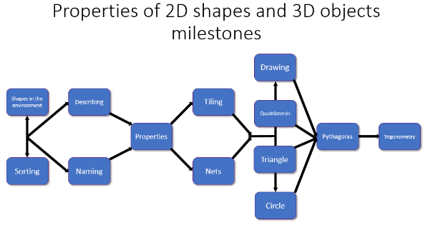
Significant aspect of learning:
Applying numeracy and mathematical skills
It is important that learners develop numeracy and mathematical skills as they build their knowledge and understanding. As learners progress, they should demonstrate an increasing sophistication in their ability to:
• interpret questions
• select and communicate processes and solutions
• justify choice of strategy used
• link mathematical concepts
• use mathematical vocabulary and notation
• use mental agility
• reason algebraically
• determine the reasonableness of a solution
These skills should be evident across the other significant aspects of learning in Numeracy and Mathematics. Staff should actively promote the development of these skills and ensure they are embedded in planning for learning, teaching and assessment.

Properties of 2D shapes and 3D objects |  | Significant aspect of learning:  Use knowledge and understanding of shape and space
 | Milestone | During Early Level |  | By the end of Early Level
I enjoy investigating objects and shapes and can sort, describe and be creative with them.  MTH 0-16a | Sorting shapes and objects | - I can sort objects using familiar or given criteria e.g. colour. |  | - I can talk about the dynamic properties of shapes e.g. it rolls, slides, stacks etc. and use these to sort shapes and objects.
 | Describing shapes and objects | - I can use language such as straight, curved, flat, corner etc. to describe objects. |  | - I use the properties of familiar objects to help me name shapes I am using e.g. wheel for circle.
 | Milestone | At the beginning of First Level | During First Level |  | By the end of First Level
I have explored simple 3D objects and 2D shapes and can identify, name and describe their features using appropriate vocabulary.  MTH 1-16a | Naming shapes and objects | - I can recognize and name a range of simple shapes such as rectangle, square, triangle and circle. | - I can recognise and name a range of simple objects such as cubes, cuboids, cones, cylinders and spheres. |  | - I have extended the range of shapes I can recognise and name, e.g. pyramids and triangular prism.
 | Describing shapes and objects | - I can describe the features of a range of simple shapes and objects using language such as side, angle, corner, face and edge. | - I can recognise that the faces of 3D objects are composed of shapes and I can describe the properties of these shapes. |  | - I have extended the range of shapes I can describe, sort and classify, e.g. pyramids and triangular prism.
I can explore and discuss how and why different shapes fit together and create a tiling pattern with them.  MTH 1-16b | Tiling | - I can choose simple shapes to make a tiling pattern. | - I can predict if a shape can tessellate or not and test my theory by drawing a tiling pattern. |  | - I can say if a range of shapes will tessellate or not based on my understanding of the properties of the shapes, e.g. rectangles and squares tessellate because right angles fit together.
 | Milestone | At the beginning of Second Level | During Second Level |  | By the end of Second Level
Having explored a range of 3D objects and 2D shapes, I can use mathematical language to describe their properties, and through investigation can discuss where and why particular shapes are used in the environment.  MTH 2-16a | Naming shapes and objects | - I can recognise and name a range of 2D shapes including polygons. | - I can recognise and name quadrilaterals e.g. rectangle, kite, trapezium, rhombus, parallelogram.  - I can recognise and name triangles e.g. equilateral, isosceles, right-angled, scalene. |  | - I can recognise and name a range of 3D objects both solid and skeletal.
 | Describing shapes and objects | - I can describe the features of a range of shapes and objects using language such as side, angle, vertex, face, edge, radius, diameter and circumference. | - I can use the properties of shapes to classify them into given groups or groups of my own design.  - I understand the terms regular, irregular, isosceles and equilateral. |  | - I can use mathematical vocabulary to describe and classify quadrilaterals.  - I can discuss why different shapes and objects are used in the environment.
Through practical activities, I can show my understanding of the relationship between 3D objects and their nets.  MTH 2-16b | Nets | - I can construct a cube or cuboid from its net. | - I can construct a range of objects from their nets. |  | - I can draw the nets for a range of 3D objects, including prisms, pyramids and other polyhedra.  - I have explored how nets are used in everyday life.
I can draw 2D shapes and make representations of 3D objects using an appropriate range of methods and efficient use of resources.  MTH 2-16c | Drawing shapes | - I can accurately draw a range of 2D shapes using a ruler, angle measure and for circles a compass. | - I can use isometric or hexagonal grid paper to make 2D representations of cubes and cuboids. |  | - I can use oblique techniques to make 2D representations of 3D objects.
 | Milestone | During Third Level |  | By the end of Third Level
Having investigated a range of methods, I can accurately draw 2D shapes using appropriate mathematical instruments and methods.  MTH 3-16a | Drawing shapes | - I have investigated and can use a range of methods to draw triangles.  - I can calculate missing sides in problem solving situations. |  | - I have investigated and can use a range of methods to draw quadrilaterals and polygons.
 | Milestone | During Fourth Level |  | By the end of Fourth Level
I have explored the relationships that exist between the sides, or sides and angles, in right-angled triangles and can select and use an appropriate strategy to solve related problems, interpreting my answer for the context.  MTH 4-16a | Pythagoras | - I have investigated and can use the Pythagorean relationship for triangles. |  | - I can use the converse of Pythagoras theorem.
 | Trigonometry | - I can find missing side lengths using trigonometric ratios.  - I can find missing angles using trigonometric ratios. |  | - I can solve problems using trigonometry including coordinate systems.  - I can choose between trigonometry and Pythagoras to solve problems in real life contexts.
Having investigated the relationships between the radius, diameter, circumference and area of a circle, I can apply my knowledge to solve related problems.  MTH 4-16b | Circle | - I have investigated and can use the relationship between the radius, diameter and circumference of a circle to solve related problems.  - I have investigated and can use the relationship between the radius and area of a circle to solve related problems. |  | - I can solve related problems for compound shapes choosing the appropriate method to apply. I recognise that there may be more than one route to find a solution to the problem.

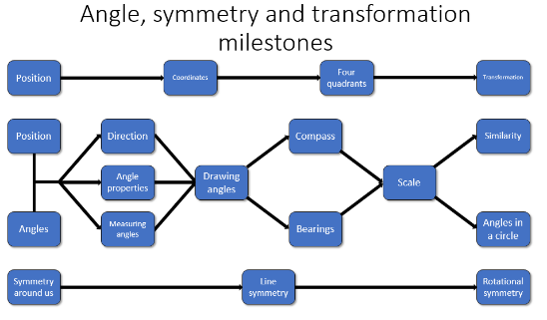
Significant aspect of learning:
Applying numeracy and mathematical skills
It is important that learners develop numeracy and mathematical skills as they build their knowledge and understanding. As learners progress, they should demonstrate an increasing sophistication in their ability to:
• interpret questions
• select and communicate processes and solutions
• justify choice of strategy used
• link mathematical concepts
• use mathematical vocabulary and notation
• use mental agility
• reason algebraically
• determine the reasonableness of a solution
These skills should be evident across the other significant aspects of learning in Numeracy and Mathematics. Staff should actively promote the development of these skills and ensure they are embedded in planning for learning, teaching and assessment.

Angle, symmetry and transformation |  | Significant aspect of learning:  Use knowledge and understanding of shape and space
 | Milestone | During Early Level |  | By the end of Early Level
In movement, games, and using technology I can use simple directions and describe positions.  MTH 0-17a | Position | - Use left and right to differentiate between identical body parts. |  | - I can describe the position of an object by using positional words such as behind, in front of, above and below.
 | Directions | - I can describe a sequence of directions, that involve turning, to a partner  - I can follow a sequence of directions that involve turning. |  | - I can program a sequence of directions into a programmable toy or similar technology.
I have had fun creating a range of symmetrical pictures and patterns using a range of media.  MTH 0-19a | Symmetry around us | - I can create a symmetry picture using a fold. |  | - I can create a symmetry picture or pattern using a flip or fold.
 | Milestone | At the beginning of First Level | During First Level |  | By the end of First Level
I can describe, follow and record routes and journeys using signs, words and angles associated with direction and turning.  MTH 1-17 | Directions | - I can give and follow verbal directions for a route or journey (supported).  - I can demonstrate half and quarter turns along with clockwise and anti-clockwise. | - I can give and follow verbal directions for a route or journey (independent).  - I can use left and quarter turn anti-clockwise as part of instructions for routes and journeys. |  | - I can investigate and create instructions for a journey that I am unfamiliar with. Producing signs or a simple plan to help others navigate.  - I can compare different angles using an angle estimator and relate my estimates to right angles.
I have developed an awareness of where grid reference systems are used in everyday contexts and can use them to locate and describe position.  MTH 1-18a | Coordinates | - I have investigated the use of grid systems; I can describe when they might be useful. | - I can find objects on a grid and give its location.  - I can plot objects onto a grid. |  | - I can describe pathways between objects on a grid, plan or map.
I have explored symmetry in my own and the wider environment and can create and recognise symmetrical pictures, patterns and shapes.  MTH 1-19a | Symmetry around us | - I can recognise symmetrical pictures patterns and shapes. | - I can describe why pictures patterns and shapes are symmetrical. |  | - I can create symmetrical pictures patterns and shapes.
 | Milestone | At the beginning of Second Level | During Second Level |  | By the end of Second Level
I have investigated angles in the environment, and can discuss, describe and classify angles using appropriate mathematical vocabulary.  MTH 2-17a | Angles | - I know the connection between quarter turns, right angles, half turns and full turns. | - I can identify right, acute, obtuse, reflex angles and full turns. |  | - I can discuss angles I have seen in the environment and can describe them using appropriate vocabulary.
I can accurately measure and draw angles using appropriate equipment, applying my skills to problems in context.  MTH 2-17b | Measuring angles | - I know the measurements of a few basic angles e.g. right angles, straight lines and full turn. | - I can use these measurements to estimate the size of an angle. |  | - I can measure angles using degrees with increasing accuracy.
 | Drawing angles | - I can draw right angles. | - I can draw right, acute, obtuse, reflex angles and full turns. |  | - I can draw angles using degrees with increasing accuracy to produce shapes and solve related problems.
Through practical activities which include the use of technology, I have developed my understanding of the link between compass points and angles and can describe, follow and record directions, routes and journeys using appropriate vocabulary.  MTH 2-17c | Compass | - I know the basic compass points and the connections with right angles. | - I know and can use the eight point compass rose.  - I can use the compass points to describe, follow and record direction routes and journeys. |  | - I know the link between the compass rose and angles. I can apply this to practical situations.  - I can use angles to describe, follow and record direction routes and journeys.
Having investigated where, why and how scale is used and expressed, I can apply my understanding to interpret simple models, maps and plans.  MTH 2-17d | Scale | - I can use the words enlargement and reduction to describe a transformation. | - I can apply a simple enlargement or reduction  - I understand that scaled objects, maps, plans keep the same shape and look. |  | - I can use and interpret simple scales on maps, plans or models.
I can use my knowledge of the coordinate system to plot and describe the location of a point on a grid.  MTH 2-18a | Coordinates | - I can find objects on a coordinate grid given its coordinates. | - I can use the notation of coordinate grids.  - I can plot coordinates on a coordinate grid. |  | - I can describe how to move from one point on a grid to another point.
I can illustrate the lines of symmetry for a range of 2D shapes and apply my understanding to create and complete symmetrical pictures and patterns.  MTH 2-19a | Line symmetry | - I can find and draw the lines of symmetry on simple pictures, patterns or objects. | - I can complete simple pictures or patterns that have line symmetry. |  | - I can create simple pictures with line symmetry, identifying where my line or lines of symmetry are.
 | Milestone | During Third Level |  | By the end of Third Level
I can name angles and find their sizes using my knowledge of the properties of a range of 2D shapes and the angle properties associated with intersecting and parallel lines.  MTH 3-17a | Angle properties | - I can find and identify right, acute, obtuse, reflex angles within 2D shapes and where a transversal crosses parallel lines.  - I can use standard notation to label and name angles. |  | - I can use the properties of parallel lines and transversals of these lines to calculate angles that are supplementary, corresponding, interior and alternate.  - I can describe and apply the angle properties of regular and irregular polygons for a range of shapes.
Having investigated navigation in the world, I can apply my understanding of bearings and scale to interpret maps and plans and create accurate plans, and scale drawings of routes and journeys.  MTH 3-17b | Bearings | - I can measure bearings on a map or plan.  - I can measure and read distance from a scale map or plan.  - I can draw bearings onto a map or plan to plot a route or journey.  - I can draw routes or journeys onto a scale map or plan. |  | - I can create a scale map or plan and record routes or journeys with bearings and distances.  - I can calculate bearings and distances from a scale map or plan.
I can apply my understanding of scale when enlarging or reducing pictures and shapes, using different methods, including technology.  MTH 3-17c | Scale | - I have explored how technology can be used to enlarge or reduce pictures.  - I can use a scale factor to enlarge a picture or shape. |  | - I have used and understand that a fractional scale factor can create a reduction.
I can use my knowledge of the coordinate system to plot and describe the location of a point on a grid.  MTH 3-18a | Coordinates | - I can find objects on a coordinate grid given its coordinates.  - I can use the notation of coordinate grids. |  | - I can plot coordinates on a coordinate grid.  - I can describe how to move from one point on a grid to another point.
I can illustrate the lines of symmetry for a range of 2D shapes and apply my understanding to create and complete symmetrical pictures and patterns.  MTH 3-19a | Line symmetry | - I can find and draw the lines of symmetry on a picture, pattern or object.  - I can complete pictures or patterns that have line symmetry. |  | - I can create pictures with line symmetry, identifying where my line or lines of symmetry are.
 | Milestone | During Fourth Level |  | By the end of Fourth Level
Having investigated the relationship between a radius and a tangent and explored the size of the angle in a semi-circle, I can use the facts I have established to solve related problems.  MTH 4-17a | Angles in a circle | - I understand the relationship between the radius and tangent to a circle. |  | - I can calculate the angles in a semi-circle and solve related problems.
I can apply my understanding of the properties of similar figures to solve problems involving length and area.  MTH 4-17b | Similarity | - I can identify when shapes are congruent or similar.  - I can calculate the scale factor. |  | - I can find missing angles and sides for similar shapes.  - I have explored the effect of changing scale on area and can solve related problems.
I can plot and describe the position of a point on a 4-quadrant coordinate grid.  MTH 4-18a | 4 Quadrants | - I can find objects on a coordinate grid given its coordinates (including a negative coordinate).  - I can use the notation of coordinate grids (including a negative coordinate). |  | - I can plot coordinates on a coordinate grid (including a negative coordinate).  - I can describe how to move from one point on a grid to another point (including a negative coordinate).
I can apply my understanding of the 4-quadrant coordinate system to move, and describe the transformation of, a point or shape on a grid.  MTH 4-18b | Transformation | - I can describe how to move from one point on a grid to another point. |  | - I can predict the result of a transformation on a point or shape and draw the result accurately on a four quadrant grid.
Having investigated patterns in the environment, I can use appropriate mathematical vocabulary to discuss the rotational properties of shapes, pictures and patterns and can apply my understanding when completing or creating designs.  MTH 4-19a | Rotational symmetry | - I can describe rotational symmetry using appropriate mathematical vocabulary.  - I can identify and discuss the rotational symmetry of shapes, pictures and patterns. |  | - I can complete pictures or patterns that have rotational symmetry.  - I can create pictures with rotational symmetry.

Aberdeenshire
Progression Framework
Numeracy and Mathematics

Section 3

Learning, Teaching and Assessment:

Professional Curriculum Tool

Learning, Teaching and Assessment: Professional Curriculum Tool

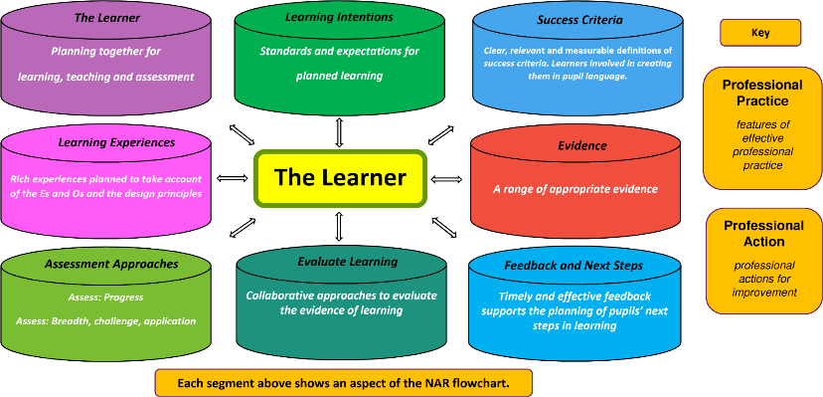

This tool can be used
- to provide an opportunity to reflect on effective practice in learning, teaching and assessment in the context of Aberdeenshire’s progression frameworks
- to allow practitioners to ‘dip into’ aspects of the learning, teaching and assessment process in order to reflect on their practice
- to inform planning for learning, teaching, moderation and assessment
- to support professional learning and/or moderation activities within a school or cluster

Key references used in this resource
- Taking a Closer Look at the National Assessment Resource (Education Scotland 2013)
- The Learning Set (Learning Unlimited 2004)
The Learner

Planning together for
learning, teaching and assessment

Use the experiences and outcomes (Es and Os) to plan your learning, teaching, assessment and moderation approaches and allow you to consider your focus for learners’ experiences.

Professional Action

Professional Practice
Learners setting goals
- help your learners ‘engage’ with their goals
- help them understand the big picture of where they are going
- give learners a structure in which to work
i.e. ask questions/try things out/make connections/ask why
- use variety of planning techniques
i.e. floor book planning/carousel/ cooperative learning group discussion/ mind maps/interactive wall displays/ KWL grids
- set group/class goals

Learner engagement
- learner should be at centre of planning for learning, teaching and assessment
- quality dialogue with learners should be embedded in practice
- principles and practice papers outline the broad features of assessment

Learning Intentions

Standards and expectations for
planned learning

The learning intention is what learners should know, understand or be able to do by the end of a learning experience.
The focus should be on what is to be learned as opposed to the task, activity or context.
By teasing out the learning from your chosen experience(s) and outcome(s), you will be able to develop learning intentions that focus specifically on what has to be learned.
When clear about the learning intention, learners will be more focused and actively engaged in their own learning. Sharing the learning intention makes it easier to give quality feedback specifically on what has been learned.

Professional Action
Professional Practice

Good learning intentions?
- use SMART criteria
- focus on the specific
- not too broad - not too difficult – not too general
- child friendly, clear language
- skill or knowledge based - not concept
- use ‘learning’ words
know/understand/learn/think/
use
- consider phrasing and
tone

Techniques to use
- display the LI
- make LI accessible while children are working
- don’t confuse LI with activity
- build the LI into the lesson introduction
- signal the LI especially to younger children
- use examples
- involve pupils in setting SC

“Research tells us that goals which are specific, clear, challenging but not outwith the student’s reach have the most effect on performance.”
Caroline Gipps
Success Criteria

Clear, relevant and measurable definitions of
success criteria.
Learners involved in creating them in pupil language.

Success criteria are suggested ways to achieve the learning intention.
Sharing success criteria enables learners to feel confident about how to achieve success in a lesson.
As you plan and consider your success criteria you should ensure that they are directly linked to your learning intentions and the evidence of learning which you will be aiming to collect.

Professional Action
Professional Practice

Techniques to use
- link to Learning Intention – “How will you know that … (link to LI) ?
- signal the SC throughout the lesson
- use examples by matching SC with a good quality piece of work
- involve pupils in the process
- focus on observable behaviours when tasks are open-ended i.e. ‘what will ‘good’ look like?’
- create a SC checklist for pupil use
- create a scoring scale for pupil use

Good success criteria?
- closely linked to learning intentions
- clear, easy to understand
- focused on how learning can be identified
- good use of ‘learning’ words
know/understand/learn/think/use
- looking at the learning not the task

Learning Experiences

Rich experiences planned to take account of the Es and Os and the design principles

challenge and enjoyment
breadth progression depth
personalisation and choice
coherence relevance

Learning experiences planned with the experiences and outcomes and design principles in mind will be rich and fulfilling.
As you plan a variety of experiences you will consider what activities will engage the learners and allow them to develop and demonstrate their knowledge and understanding, skills, attributes and capabilities.

Professional Practice

Professional Action
Collegiate discussions (moderation)
- with a colleague, discuss examples of your practice where you have met any or all of the seven design principles
- with a colleague, and using an experience and outcome of your choice, have a go at planning a set of learning experiences which would develop the seven design principles

Setting Es and Os in context
- know your children and your community – this will help engage them in their learning
- look at your plans and try to highlight the seven design principles
- refer to the Aberdeenshire frameworks
- read the Assessing Progress and Achievement curricular papers

A range of appropriate evidence
Evidence

Product – artwork, report, project
Learners’ Records of Assessment

It is essential that staff use evidence of learning from a broad range of contexts to check how a learner is progressing and that learning is secure. The evidence will be different depending upon the kind of learning being assessed, the learning activity and learners’ preferences about how to show what they have learned.
Evidence will come from day-to-day learning as well as from specific assessment tasks. The National Assessment Resource can help practitioners when deciding on what learners would need to say, write, do or make to demonstrate success.
Consideration should be given on how to reflect, share, discuss and agree these expectations with learners and with colleagues.

Written Responses

Observation
Dialogue

Professional Action

Professional Practice
Collegiate discussions (moderation)
- with a colleague, look at evidence you have gathered for a learning experience and agree if it fits with the original planning outline
- discuss whether or not the evidence is valid, reliable and proportionate (balanced)
- with a colleague, plan a variety of possible evidence

Evidence of learning
- match planned evidence with kind of learning being assessed
- engage pupils with Es and Os
- pupils help identify learning focus
- pupils select appropriate methods of assessment to inform range of evidence: make-say-write-do
- evidence should match Es and Os

Assessment Approaches
Assess: Progress
Assess: Breadth, challenge and application

Teachers need a range of assessment approaches to assess the different types of achievement across the curriculum. This range allows learners to demonstrate what they know, understand and can do.
The range and variety of assessment approaches should take account of the relevance of contexts to learners’ prior experiences, interests and aspirations and should link across learning where possible.
Teachers need to consider learning in terms of breadth, challenge and application.

Professional Practice

Professional Action

Assessment across learning
Ensure your planning takes account of
- Progression across levels
- Breadth
the number and range of experiences and outcomes encountered by learners
- Challenge
the attributes, capabilities and skills (including higher order thinking skills) which are embedded in learning and may be planned through personalisation and choice
- Application
application refers to how knowledge and understanding, attributes, capabilities and skills (including higher-order thinking skills) are used in new and unfamiliar contexts so that they become transferable and secure - it is about learners becoming flexible and adaptable in the way they apply their learning

Using Assessment Approaches
- with a colleague, look at assessment approaches you have used and identify how breadth, challenge and application have been taken into account
- with a colleague, plan for breadth, challenge and application for a group of experiences and outcomes you plan to teach
- when planning, devise LIs and SC that will span across a level(s) in order to allow for progression
- to support differentiation, provide learners with opportunities to express how challenged they feel in their learning and how they think they are progressing

Collaborative approaches to evaluate
the evidence of learning

Evaluate Learning

Evaluating the learning involves you in both considering the progress of each learner and considering the impact of the learning on the whole class/group.
Consistent judgements are made when staff have been collaboratively planning at all of the steps in the process.
When learners reflect on their own learning, they come to understand what they have achieved, what they can do to improve and how to go about it.

Professional Practice
Professional Action

Approaches to evaluating learning
- use examples of completed (anonymous) work as a focus for group or class discussion
- train, support and encourage learners to develop the skills of self-assessment
- train, support and encourage learners to develop the skills of peer-assessment
- plan self/peer-assessment opportunities alongside the curriculum learning and teaching
- adapt teaching to take account of learner feedback
- ensure learning is evaluated effectively and collaboratively against SC

Reflecting on learning
- learners can be helped to reflect on what they have understood and where they still need help or further explanation
- learners should be helped and carefully monitored as they learn how to self-assess
- learner self-assessment should not be a ‘bolt-on’ activity
- learner feedback from self-assessment informs planning
- other people in the learning community should be involved in evaluating progress in learning

Feedback and Next Steps

Timely and effective feedback is essential for effective learning and teaching because it helps the planning of pupils’ next steps in learning.

The quality of dialogue in feedback is very important and oral feedback can be more effective than written feedback.
Written feedback is more helpful to learning if it is in the form of comments and not marks or grades.

Professional Action
Professional Practice
Effective feedback
- is part of a supportive ethos in which pupils ask for help when they feel they need it
- indicates positive aspects of work
- provides time to discuss with learners the links between their work and the LIs and SC
- helps learners to move on in their learning
- gives suggestions for improvement
- encourages learners to think things through for themselves

Feeding back and next steps
- with a colleague, discuss examples of your practice where learners were given time to reflect, use their feedback and identify next steps
- plan time for learners and peers to reflect on the advice and guidance received and identify next steps
- teach pupils how to be reflective
~ use questions to focus feedback
~ encourage rather than praise
e.g. tell me more/for instance?/so?
~ prompt and probe to extend thinking
~ keep comments positive and specific

