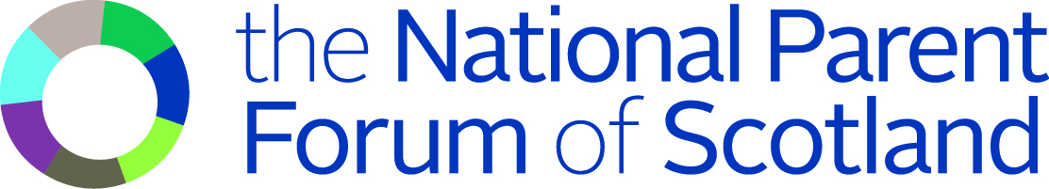

Scottish Government consultation on the statutory guidance for the GIRFEC duties in the Children and Young People (Scotland) Act

The Scottish Government has launched a public consultation on the statutory guidance for Parts 4, 5 and 18 of the Children and Young People (Scotland) Act 2014.

The National Parent Forum of Scotland (NPFS) welcomes the consultation as it provides parents with an opportunity to discuss the guidance and the implications it will have for parents and families. We broadly support the overall aims of Getting it Right for Every Child, and encourage the Scottish Government to ensure that parents’ views on the guidance are listened to and that their feedback is reflected in the final version of the guidance.

What is the statutory guidance?

The Children and Young People (Scotland) Act 2014 is a new law which introduces a number of duties including the Named Person and the Child’s Plan. It also provides a definition of ‘wellbeing’. These duties are part of the Getting it Right for Every Child (GIRFEC) approach, which is the Scottish Government’s overarching policy in relation to children and young people. It aims to ensure that the best interests of the child are always placed at the centre of any policy or practice affecting them.

The statutory guidance provides details on how the GIRFEC duties will work, and is aimed at the bodies who are responsible for carrying out these duties - local authorities, health boards and other bodies. However, parents, children and young people will also be interested in the guidance, as the new duties will affect them directly.

The guidance includes the following:

- How the Named Person role should be carried out
- How other services should support the Named Person role
- How and when professionals should share information under the Act and the protections in place to prevent inappropriate sharing of information
- How and when the Child's Plan should be put together and used
- What 'wellbeing' means in the context of the new Act

What will the consultation involve?

The public consultation will last for three months starting from Friday 6th February 2015. Anyone can comment on the guidance and there are many ways to respond. NPFS intends to submit a response, which will be informed by parents’ views. We would encourage parents and parent councils to respond as well.

It’s important to note that the consultation is an opportunity to comment on the guidance but not the law itself, as this has already been enacted.

The full consultation, including details of how to respond, is available on the Scottish Government website: http://www.scotland.gov.uk/Consultations/Current

What are the next steps?

The final version of the statutory guidance will be published in summer 2015. The views expressed in the consultation responses will be taken into consideration in the final drafting of the guidance, but it is up to the Scottish Government to decide how, and whether, to incorporate the feedback they have received.

